AKN4EU 4.2
PART 2 – Document types

History
Version 4.2 | - Council acts and proposals (WP 6.1.1)  - PART 2.1 – 1 modify the introduction to cover the Council legal act.  - PART 2.1 – 2 include “attachment” as component of an EU act  - PART 2.1 – 3.5.2 add <placeholder> in <longTitle>  - PART 2.1 – 3.9.2 add <attachment> for the “Table of annexes”  - PART 2.1 – 3.9.3 add <attachment> for the “attachment” of an EU act  - PART 2.1 - 4.4 <mainBody>:  - replace "intermediar structures" by "core structures" and put it at the top of the list as it can arrive alone, without any high level structures.  - add <article> as possible core structure ; independent subject can be mixed with <article>  - remove the description for article and level and replace it by reference to the AKN4EU PART 1.  - add a PART 2.1 - 4.5 <attachments>, for the annex(es) of an annex  - PART 2.3 - 1 : add use case for the "attachment" of a legal text in Proposal for an act.  - PART 2.3 – 3.3 change to take into account the step in procedure is optional  - PART 2.3 - 4.5 : add the mark-up for a short Explanatory Memorandum without section.  - INTERNAL_DOC_CONSIL with draft DEC (WP 6.1.2)  - add a PART 2.3 – 1.4 for the case ‘Council internal document with (draft) act  - in PART 2.5 – 3.5 Examples: add the case with a draft act.  - Add a PART 2.5 – 3.6.4 The Council internal document with (draft) act  - Council IMPL_DEC and PROP (WP 6.1.3 - 6.1.4)  - PART 2.1 – 1 add Implementation Decision as act type  - PART 2.1 – 3.2 add “DEC_IMPL” as possible value for @name attribute  - PART 2.3 – 1 add Proposal for a Council Implementing Decision as use case  - PART 2.3 – 2 the <bill> can be a “DEC_IMPL”  - PART 2.3 – 3.4.5 add example of <longTitle> for Proposal for Council Implementing Decision .  - Add a PART 2.3 – 4.5.1 for “unnumbered paragraphs” before sections in Explanatory Memorandum + after PART 2.3 – 4.5.3, add an example of an overall <mainBody> with this case  - OLP cover pages for EC documents (WP 6.2.4)  - modify PART 2.3 - 3.4.3 to cover the COM internal identifier .  - add a new PART 2.3 - 3.4.5 for corrigenda and addenda information  - add a new PART 2.3 – 3.4.6 for authentic language(s) information  - add a new PART 2.3 - 3.4.7 for package title  - modify PART 2.3 - 3.4.8 (previously PART 2.3 - 3.4.5) to introduce note in the <longTitle>.  - add a new PART 2.3 - 3.4.9 notes in <coverPage>  - Joint PROP for a Council REG (WP 6.1.5)  - modify PART 2.3 - 3.4.3 to cover the COM number in the case of Joint Proposal.  - modify PART 2.3 - 3.4.2 to cover Joint Proposal  - CONS Fragment of a bill (WP 6.1.6 ; 6.3.2)  - Add a new PART 2.5 – 5.2 Fragment(s) of a consolidated version of a document  - Legacy structures on import (WP 6.3.1)  - PART 2.1 – 4.4 modify the content of the section to introduce “crossheading” (<block name=”crossheading” and <crossheading> mark-up  - Corrections  - For any document types except <documentCollection>, in the section “overall organization”, remove  “<coverPage> allowed but out of the scope of AKN4EU”  - In PART 2.5 – 5.1 complete the structure (section PART 2.5 – 5.1.4 <preface>, PART 2.5 – 5.1.5 <body>, PART 2.5 – 5.1.6 <conclusions>)  - PART 2.3 – 3.4.10: update the ELI URI for associated documents according to ELI URI for preparatory document specification
Version 4.1.1 Errata | - PART 2.3 – 6 New component in Proposal for an Act : the Legislatif Financial and Digital Statement in replacement of Legislative Financial Statement
Version 4.1.1 | - New numbering of the sections of the specification, to include in the numbering, the PART number.  - Remove the “_” as first character of @xml:id  - Specification of the Financial statement part of the Proposal for an Act  - Corrections  - PART 2.2 – 4.4  Correction of the sentence regarding the <mainBody> of annexes of International Agreement.  - p 41, in example  replace ‘xml:id=”_REG”’ by ‘xml:id=”ANNEX”’

Table of content
PART 2.1 EU acts 9
PART 2.1 - 1 EU acts : use cases for AKN4EU 10
PART 2.1 - 2 AKN4EU mark-up of the EU acts: overall structure 11
PART 2.1 - 3 The AKN4EU mark-up of the main part of the EU acts 13
PART 2.1 - 3.1 <act> or <bill> 13
PART 2.1 - 3.2 @name attribute 13
PART 2.1 - 3.3 Overall organization 14
PART 2.1 - 3.4 <meta> 15
PART 2.1 - 3.5 <preface> 16
PART 2.1 - 3.5.1 <container name="procedureIdentifier"> 16
PART 2.1 - 3.5.2 <longTitle> 16
PART 2.1 - 3.5.3 <container name="eeaRelevance"> 21
PART 2.1 - 3.6 <preamble> 22
PART 2.1 - 3.6.1 <formula> 22
PART 2.1 - 3.6.2 <citations> 22
PART 2.1 - 3.6.3 <recitals> 23
PART 2.1 - 3.7 <body> 24
PART 2.1 - 3.7.1 <article> 24
PART 2.1 - 3.7.2 <part><title><chapter><section><subsection> 26
PART 2.1 - 3.7.3 <clause> 27
PART 2.1 - 3.8 <conclusions> 27
PART 2.1 - 3.8.1 <references> section of the metadata for the <conclusions> 27
PART 2.1 - 3.8.2 Structure of <conclusions> 28
PART 2.1 - 3.9 <attachments> 29
PART 2.1 - 3.9.1 <attachment> for “annex” 29
PART 2.1 - 3.9.2 <attachment> for “Table of annex” 30
PART 2.1 - 3.9.3 <attachment> for “attachment” 30
PART 2.1 - 4 Annex 32
PART 2.1 - 4.1 Overall organization 32
PART 2.1 - 4.2 <meta> 32
PART 2.1 - 4.3 <preface> 33
PART 2.1 - 4.4 <mainBody> 34
PART 2.1 - 4.4.1 High level structures 34
PART 2.1 - 4.4.2 Core structures 34
PART 2.1 - 4.4.3 “crossheading” 35
PART 2.1 - 4.4.4 Low level structures 35
PART 2.1 - 4.5 <attachments> 35
PART 2.1 - 4.5.1 annex of an annex 35
PART 2.2 International Agreement 37
PART 2.2 - 1 International Agreements : use cases for AKN4EU 38
PART 2.2 - 2 AKN4EU mark-up of the International Agreement: overall structure 39
PART 2.2 - 3 The AKN4EU mark-up of the main part of the International Agreement 40
PART 2.2 - 3.1 <act> or <bill> 40
PART 2.2 - 3.2 @name attribute 40
PART 2.2 - 3.3 Overall organization 40
PART 2.2 - 3.4 <meta> 40
PART 2.2 - 3.5 <preface> 41
PART 2.2 - 3.5.1 <longTitle> 41
PART 2.2 - 3.6 <preamble> 42
PART 2.2 - 3.6.1 <heading> 42
PART 2.2 - 3.6.2 <recitals> 43
PART 2.2 - 3.7 <body> 43
PART 2.2 - 3.8 <conclusions> 43
PART 2.2 - 3.8.1 Place and date 43
PART 2.2 - 3.8.2 Signatory 44
PART 2.2 - 3.9 <attachments> 45
PART 2.2 - 3.10 <attachment> 45
PART 2.2 - 4 The AKN4EU mark-up of the Annex 47
PART 2.2 - 4.1 Overall organization 47
PART 2.2 - 4.2 <meta> 47
PART 2.2 - 4.3 <preface> 48
PART 2.2 - 4.4 <mainBody> 48
PART 2.2 - 4.5 <attachment> 48
PART 2.3 Proposal for an act 49
PART 2.3 - 1 Proposal for an act : use cases for AKN4EU 50
PART 2.3 - 2 AKN4EU mark-up of the Proposal for an act: overall structure 53
PART 2.3 - 3 The mark-up of the <documentCollection> 55
PART 2.3 - 3.1 @name attribute 55
PART 2.3 - 3.2 Overall organization 55
PART 2.3 - 3.3 <meta> 55
PART 2.3 - 3.4 <coverPage> 57
PART 2.3 - 3.4.1 <container name="logo"> 57
PART 2.3 - 3.4.2 <container name="actingEntity"> 57
PART 2.3 - 3.4.3 <container name="mainDoc"> 59
PART 2.3 - 3.4.4 <container name="procedureIdentifier"> 61
PART 2.3 - 3.4.5 <container name="corrigendum"> and <container name=”addendum”> 61
PART 2.3 - 3.4.6 <container name="packageTitle”> 62
PART 2.3 - 3.4.7 <longTitle> 63
PART 2.3 - 3.4.8 Notes in <coverPage> 64
PART 2.3 - 3.4.9 <container name="eeaRelevance"> 65
PART 2.3 - 3.4.10 <container name="associatedReferences"> 66
PART 2.3 - 3.4.11 <container name="mainDocLanguage"> 66
PART 2.3 - 3.5 <collectionBody> 67
PART 2.3 - 3.5.1 <component> for the Explanatory Memorandum 67
PART 2.3 - 3.5.2 <component> for legal text 67
PART 2.3 - 3.5.3 <component> for the Legislative Financial Statement 67
PART 2.3 - 4 The mark-up of the Explanatory Memorandum 68
PART 2.3 - 4.1 @name attribute 68
PART 2.3 - 4.2 Overall organization 68
PART 2.3 - 4.3 <meta> 68
PART 2.3 - 4.4 <preface> 68
PART 2.3 - 4.5 <mainBody> 69
PART 2.3 - 4.5.1 The “unnumbered paragraph(s)” before the “section(s)” 69
PART 2.3 - 4.5.2 The section: <tblock> 69
PART 2.3 - 4.5.3 The specific content of a section: <blockContainer> 69
PART 2.3 - 5 The mark-up of the Legal Text 72
PART 2.3 - 5.1 @name attribute 72
PART 2.3 - 5.2 Overall organization 72
PART 2.3 - 6 The mark-up of the Legislative Financial and Digital Statement and of the Legislative Financial Statement 73
PART 2.3 - 6.1 @name attribute 73
PART 2.3 - 6.2 Overall organization 73
PART 2.3 - 6.3 <meta> 73
PART 2.3 - 6.4 <preface> 73
PART 2.3 - 6.5 <mainBody> 74
PART 2.3 - 6.5.1 Core structure: element <level> 74
PART 2.3 - 6.5.2 Low level structures 75
PART 2.4 EP Texts adopted 78
PART 2.4 - 1 EP Text Adopted : use cases for AKN4EU 79
PART 2.4 - 1.1 Case 1: Legislative resolution alone 79
PART 2.4 - 1.2 Case 2: Legislative resolution and Consolidated text in the context of an agreement with the Council 80
PART 2.4 - 2 AKN4EU mark-up of the EP Texts adopted: overall structure 81
PART 2.4 - 3 The mark-up of the <documentCollection> 82
PART 2.4 - 3.1 @name attribute 82
PART 2.4 - 3.2 <meta> 82
PART 2.4 - 3.3 <coverPage> and <preface> 84
PART 2.4 - 3.3.1 <coverPage> 84
PART 2.4 - 3.3.2 <preface> 85
PART 2.4 - 3.4 <collectionBody> 86
PART 2.4 - 3.4.1 <component> for the Legislative Resolution 86
PART 2.4 - 3.4.2 <component> for the Consolidated text abridged 86
PART 2.4 - 4 The mark-up of the Legislative resolution 88
PART 2.4 - 4.1 @name attribute 88
PART 2.4 - 4.2 Overall organization 88
PART 2.4 - 4.3 <meta> 88
PART 2.4 - 4.4 <preface> 89
PART 2.4 - 4.5 <preamble> 91
PART 2.4 - 4.6 <body> 92
PART 2.4 - 5 The mark-up of the Consolidated text abridged 93
PART 2.4 - 5.1 @name attribute 93
PART 2.4 - 5.2 Overall organization 93
PART 2.4 - 5.3 <meta> 93
PART 2.4 - 5.4 <preface> 94
PART 2.4 - 5.4.1 <container name="mainDoc"> 94
PART 2.4 - 5.4.2 <longTitle> 94
PART 2.4 - 5.4.3 <container name="abridgedTextComment"> 95
PART 2.4 - 5.5 <preamble> 95
PART 2.4 - 5.6 <body> 96
PART 2.5 Council documents 97
PART 2.5 - 1 Council documents: use cases 98
PART 2.5 - 1.1 Council internal documents in general 98
PART 2.5 - 1.2 Statement of the Council's Reasons 100
PART 2.5 - 1.3 Position of the Council 100
PART 2.5 - 1.4 Council internal document with (draft) act 101
PART 2.5 - 2 AKN4EU mark-up of the Council documents: overall structure 102
PART 2.5 - 3 The mark-up of the <documentCollection> 103
PART 2.5 - 3.1 The @name attribute 103
PART 2.5 - 3.2 <meta> 103
PART 2.5 - 3.3 <coverPage> 105
PART 2.5 - 3.3.1 <container name="logo"> 106
PART 2.5 - 3.3.2 <container name="actingEntity"> 106
PART 2.5 - 3.3.3 <container name="mainDoc"> 106
PART 2.5 - 3.3.4 < container name="procedureIdentifier"> 107
PART 2.5 - 3.3.5 <container name="mainDocReference"> 107
PART 2.5 - 3.3.6 <container name=”subjectMatter”> 108
PART 2.5 - 3.3.7 <container name="distribution"> 108
PART 2.5 - 3.3.8 <container name="docHeader"> 109
PART 2.5 - 3.4 <collectionBody> 112
PART 2.5 - 3.4.1 <component> 112
PART 2.5 - 3.5 Examples 112
PART 2.5 - 3.5.1 The general case of Council internal document 113
PART 2.5 - 3.5.2 Statement of Council's reasons 115
PART 2.5 - 3.5.3 The Position of the Council 116
PART 2.5 - 3.5.4 The Council internal document with (draft) act 118
PART 2.5 - 4 The mark-up of the 'Council Explanatory' subdocument 120
PART 2.5 - 4.1 The @name attribute 120
PART 2.5 - 4.2 Overall organization 120
PART 2.5 - 4.3 <meta> 120
PART 2.5 - 4.4 <preface> 120
PART 2.5 - 4.5 <mainBody> 121
PART 2.5 - 4.5.1 The structures 121
PART 2.5 - 4.5.2 The representation in AKN4EU 121
PART 2.5 - 5 The mark-up of the CNSDocANN 124
PART 2.5 - 5.1 Act or bill 125
PART 2.5 - 5.1.1 The @name attribute 125
PART 2.5 - 5.1.2 Overall organization 125
PART 2.5 - 5.1.3 <meta> 126
PART 2.5 - 5.1.4 <preface> 126
PART 2.5 - 5.1.5 <body> 126
PART 2.5 - 5.1.6 <conclusions> 126
PART 2.5 - 5.2 Fragment(s) of consolidated version of a document 127
PART 2.5 - 5.2.1 Introduction 127
PART 2.5 - 5.2.2 The AKN4EU content of the CNSDocANN 127
PART 2.5 - 5.3 Document (Council conclusions for example) 130
PART 2.5 - 5.3.1 Overall organization 130
PART 2.5 - 5.3.2 <meta> 130
PART 2.5 - 5.3.3 <preface> 130
PART 2.5 - 5.3.4 <mainBody> 131
PART 2.5 - 5.3.5 Examples 132

EU acts

EU acts : use cases for AKN4EU
The AKN4EU baseline version contains the following use cases for the EU acts:
- Decision
- Directive
- Regulation
- Implementing Decision
This covers Acts that are adopted following the OLP (= Ordinary Legislative Procedure) as well as their drafting version during the legislative process but also acts that are adopted following other procedures, like the Council legal acts. The structure of an EU act, according to the CoV is the following
Title of the document
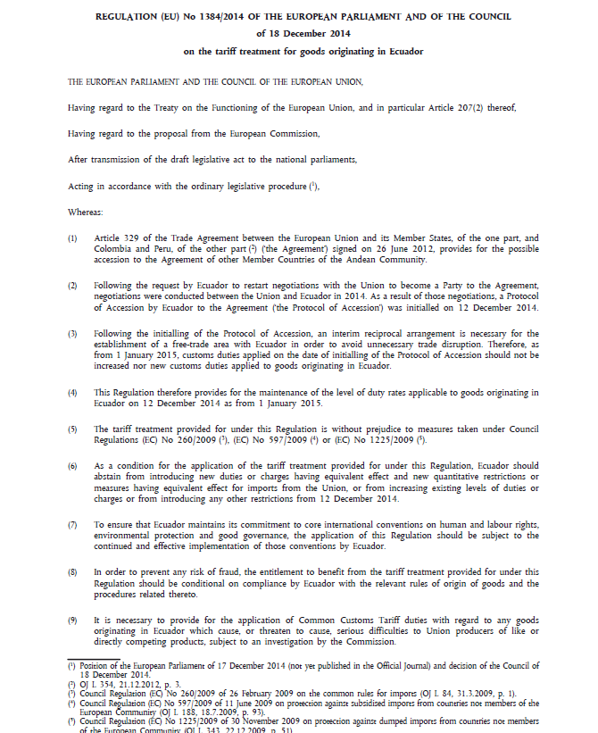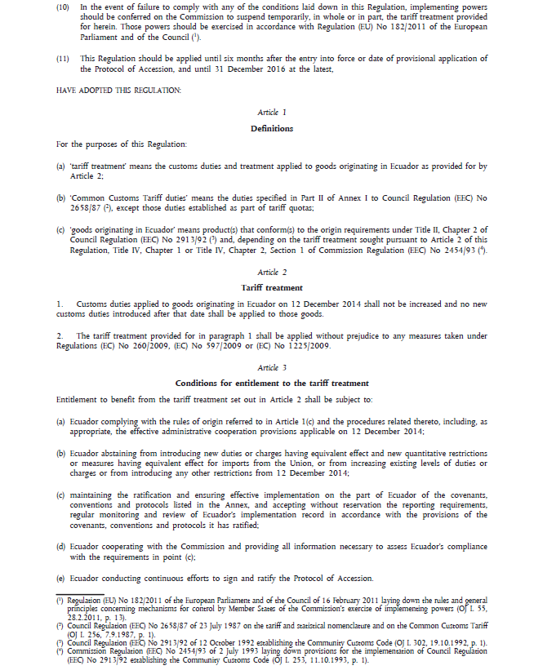
Enacting terms
preamble
article
recitals
citations
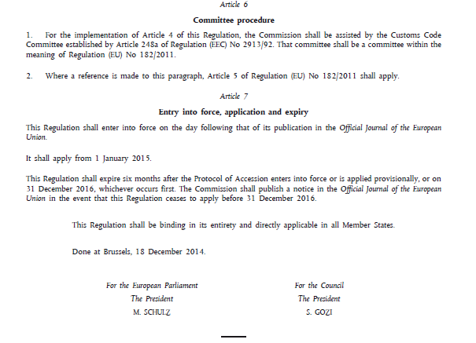
Direct applicability
signature
signatories
annex

AKN4EU mark-up of the EU acts: overall structure
The main part of an EU act, containing the title of the document, the preamble, the enacting terms and the signatures is in one AKN4EU file. It is marked as an <act> or a <bill> (see after).
An EU act can contain one or more annex(es). Annexes can be embedded at multiple levels, so it is possible to have, e.g., an annex to annex. The following rules apply:
- For each top-level annex, there must exist one <attachment> element inside the <attachments> section of the <act> or the <bill> ;
- For each embedded annex, there must exist an <attachment> element inside the <attachments> section of the higher-level annex;
- The content of each annex MUST be in a specific AKN4EU file;
- Each annex is marked with the element <doc>.
Sometimes, the annexes are preceded by a special component “List of annexes”. The first annex after it is numbered “1”.
"DEC" "DIR" or "REG" or “DEC_IMPL"
<act> or <bill>

An EU act or bill can also have attachment(s) containing other legal acts.
These are attachments and not annexes.
In this case, the following rules apply:
- For each “attachment”, there MUST exist an <attachment> element inside the <attachments> section of the <act> or the <bill> where it is attached.
- This <attachment MUST have a @refersTo that points to an entry of the <references> part of the metadata that refers the authority code “ATTACHMENT”.
This attribute is essential to differentiate an ‘annex’ from an ‘attachment’.
In a further step of the legislative workflow, the attachment can be detached as it is not part of the EU act.
- When an attachment to an act is labelled with a word like “ANNEX”, “ATTACHMENT” etc., this word is put inside a <num> element of the corresponding <attachment> element
- The content of each attachment MUST be in a specific AKN4EU file;
Each attachment is marked with an <act>, <bill>, <doc> depending on the document type of the attachment
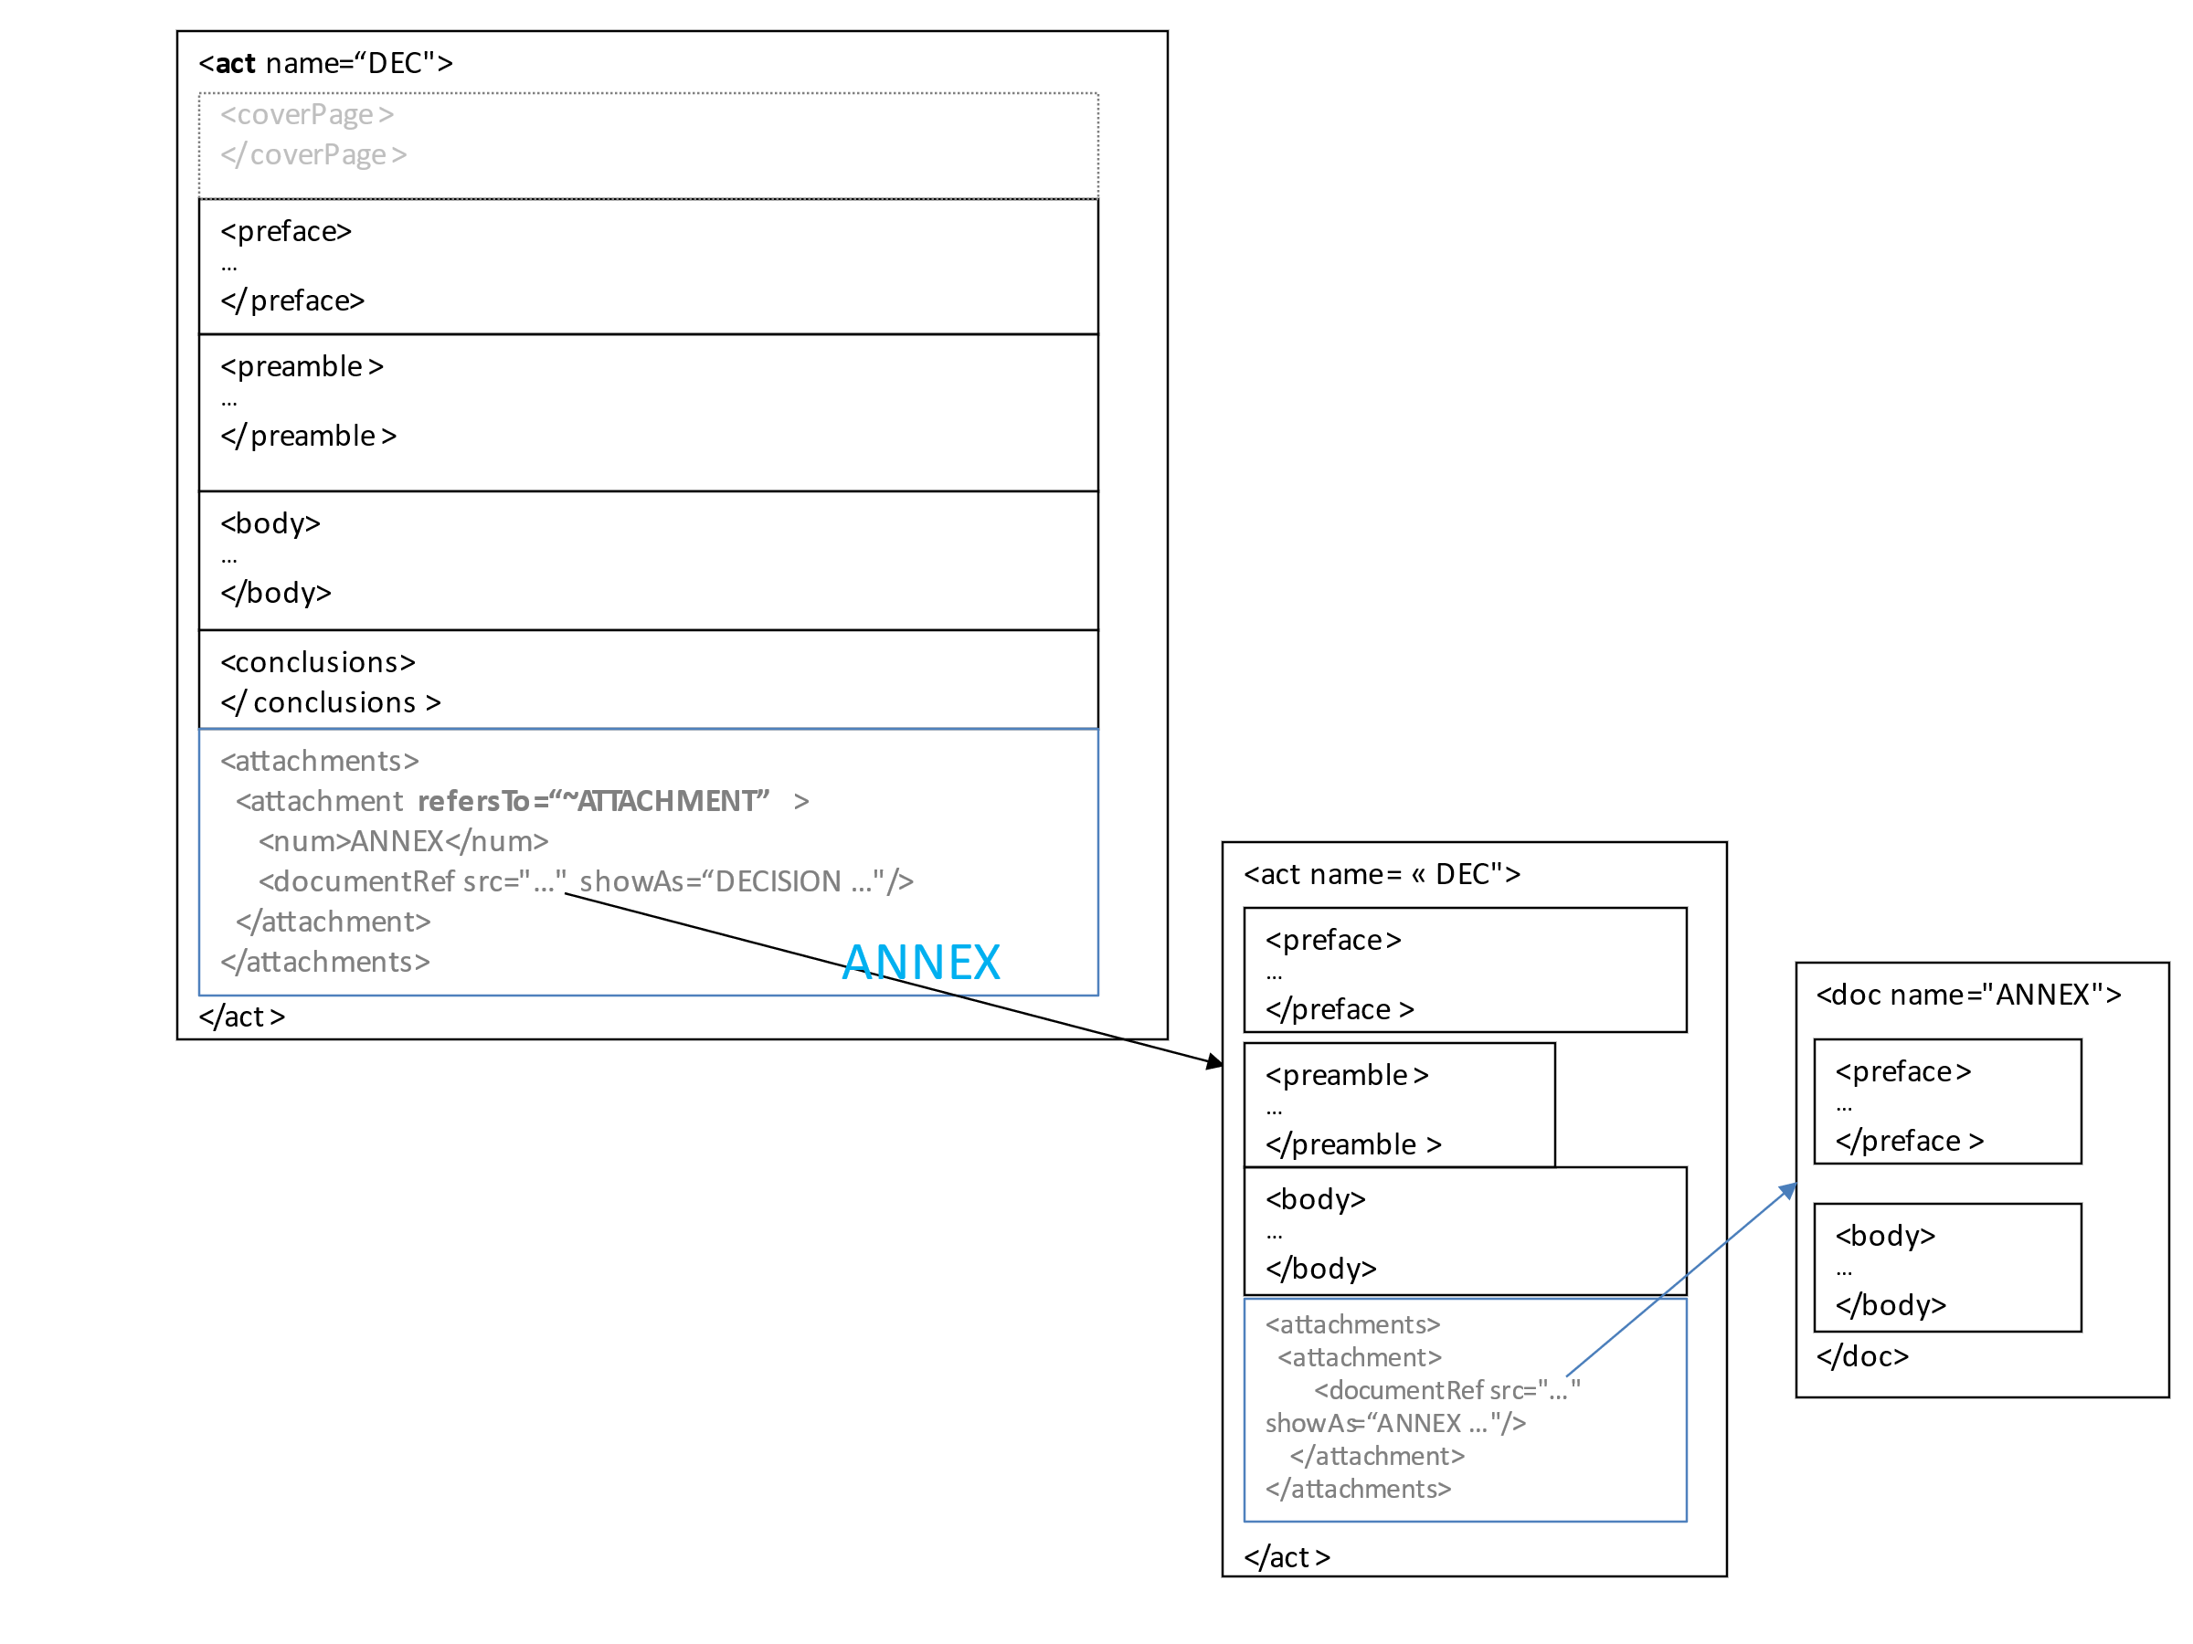

The AKN4EU mark-up of the main part of the EU acts

<act> or <bill>
Akoma Ntoso uses two elements to mark up a legal text:
- <act>, for the final version that is published in the Official Journal;
- <bill>, for the main part of any draft version of the legal text during the legislative/legal process.
Accordingly, in AKN4EU,
- Decisions, Directives, Regulations and Implementing Decisions, when published in the Official Journal, are marked as <act>
- A draft version of what may become, at the end of the legislative/legal procedure, an act, is marked as a <bill>.
It can be the legal text proposed in the Proposal for a Decision, the Proposal for a Directive; the Proposal for a Regulation or the Proposal for an Implementing Decision, issued from the Commission and that initiates the Legislative/legal Procedure or it can be a Draft act (Draft Decision for example) inside a Council internal document.
Similarly, this description is applicable to the ‘EP Consolidated text’ which marks the Position of the European Parliament regarding the legal text included in the Proposal from the Commission. It is, in fact, a new version of this legal text, in form of a text consolidating all amendments adopted by the Parliament (with all the changes appropriately marked)
It is also applicable to the Position of the Council for the version of the drafted legal text it contains.

@name attribute
<act> or <bill> MUST have a @name attribute, used in AKN4EU to define the type of act.
In AKN4EU, the value of this attribute MUST be the code of an entry of the Named Authority List ‘Resource type’ (https://publications.europa.eu/en/web/eu-vocabularies/at-dataset/-/resource/dataset/resource-type).
The following values for the attribute @name are used:
Value of the attribute @name  for <act> or <bill> | Description
"DEC" | - Decision  - Any draft version of a Decision.
"DIR" | - Directive  - Any draft version of a Directive.
"REG" | - Regulation  - Any draft version of a Regulation.
“DEC_IMPL” | - Implementing Decision  - Any draft version of an Implementing Decision

Overall organization
<act> and <bill> for EU acts have the following structure:
- <meta> mandatory (metadata)
- <preface> mandatory
- <preamble> mandatory
- <body> mandatory
- <conclusions> mandatory
- <attachments> mandatory if there is one or more annex(es) or attachments

CoV  terminology  Regulation | Example | AKN4EU elements  <act name="REG">  <meta>
Title of the document  preamble  enacting terms  signature | Done at Strasbourg, 25 October 2017.  For the European Parliament For the Council  The President The President  A. TAJANI M. MAASIKAS  Article 1  Subject matter  This Regulation establishes provisions aiming to safeguard the security of gas supply in the Union by ensuring the  …  This Regulation shall be binding in its entirety and directly applicable in all Member States.  THE EUROPEAN PARLIAMENT AND THE COUNCIL OF THE EUROPEAN UNION,  Having regard to the Treaty on the Functioning of the European Union, and in particular Article 194(2) thereof,  Having regard to the proposal from the European Commission,  …  Acting in accordance with the ordinary legislative procedure (2),  Whereas:  - Natural gas (gas) remains an essential component of the energy supply of the Union. A large proportion of such gas is imported into the Union from third countries.  …  HAVE ADOPTED THIS REGULATION:  REGULATION (EU) 2017/1938 OF THE EUROPEAN PARLIAMENT AND OF THE COUNCIL  of 25 October 2017  concerning measures to safeguard the security of gas supply  and repealing Regulation (EU) No 994/2010  (Text with EEA relevance) | <preface>  <longTitle>  <preamble>  <body>  <conclusions>

<meta>
The following metadata are required:
- The metadata required by AKN4EU (see AKN4EU PART1 – section 9.5),
The @value of the <FRBRprescriptive> metadata MUST be set to "true".
- In <references>, a <TLCReference name="docType"> MUST exist, with the information on the entry in the authority table "resource-type" corresponding to the value of the @name attribute of the <documentCollection> (the value of the attribute @name MUST be the authority code)
Example
<act name="REG">
<meta>
...
<references source="~...">
...
<TLCReference xml:id="REG" name="docType"
href="http://publications.europa.eu/resource/authority/resource-type/REG"
showAs="Regulation"/>
...
</references>
</meta>
...
</act>
- In <references>, a <TLCReference name="procedureReference"> SHOULD exist, if the document is associated to a legislative/legal procedure (MANDATORY when a procedure is defined in the <preface>). As fourth indication of the @shortForm attribute, the step inside the legislative/legal procedure CAN be indicated if this information exists for the current legislative/legal procedure.
Example
<TLCReference xml:id="procedure_2011_458" name="procedureReference"
href="http://eur-lex.europa.eu/procedure/EN/2011_458" showAs="2011/0458 (COD)"
shortForm="2011/458/COD/RDG1"/>

- A corresponding <TLCProcess> CAN exist to make an explicit link between the step inside the legislative procedure and the corresponding entry in the authority table:
<TLCProcess xml:id="RDG1" href="http://publications.europa.eu/resource/authority/procedure-phase/RDG1" showAs="First reading"/>

With the following example (No <TLCProcess> is needed):

<TLCReference xml:id="procedure_2020_165" name="procedureReference"
href="http://eur-lex.europa.eu/procedure/EN/2020_165" showAs="2020/0165 (CNS)"
shortForm="2020/165/CNS"/>

<preface>
The <preface> can contain the following containers:

<container name="procedureIdentifier">
This container is only available for <bill> when exists a legislative/legal procedure. It contains the identifier and the type of the legislative/legal procedure.
The container contains a <p> element. The identifier and the type of the legislative/legal procedure MUST be inside a <docketNumber> element.
The <docketNumber> element MUST have a @refersTo attribute that points to the corresponding <TLCReference name="procedureReference">
Example

Will be marked as the following
<meta>
<TLCReference xml:id="procedure_2016_411" name="procedureReference"
href="http://eur-lex.europa.eu/procedure/EN/2016_411"
showAs="2016/0411(COD)" shortForm="2016/411/COD/RDG1"/>
</references>
</meta>
...
<container name="procedureIdentifier">
<p><docketNumber refersTo="~procedure_2016_411">2016/0411 (COD)</docketNumber></p>
</container>

<longTitle>
The <longTitle> is used to mark the title of the document.
The <longTitle> MUST contain only one <p> that can contain the following elements:
- <docStage>
- <docType>
- <docPurpose>
<placeholder> can also be present when needed.

<docStage>
<docStage> CAN ONLY be used for <bill>.
It allows to mark the part of the type of the document that is related to the type of draft version.
For example
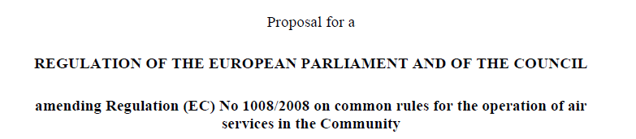
<longTitle>
<p><docStage>Proposal for a</docStage>
… </p>
</longTitle>
…
<docStage> CAN contain
- a <docType>.
The <docType> inside the <docStage> indicates the role of the draft in the legislative/legal procedure.
- A <date> if there is a date in the text. The <date> element has a mandatory attribute @date.
Example
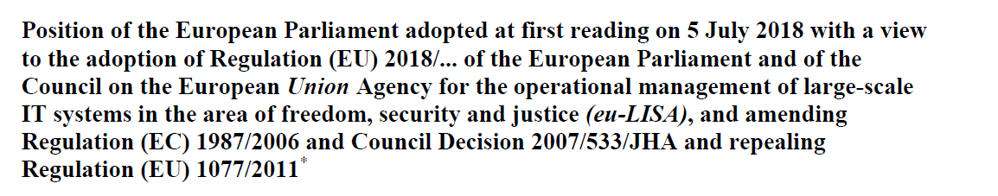
Will be marked as
…
<longTitle>
<p><docStage><docType>Position of the European Parliament</docType> adopted at first reading on <date date="2018-07-05">5 July 2018</date> with a view to the adoption of</docStage>
…
</p>
</longTitle>
…

<docType>
<docType> MUST be used to mark the line containing the type of the <act> or <bill>.
The mandatory attribute @refersTo points to the corresponding <TLCReference name="docType">.
In <act>, the line containing the type of the act contains the number of the act.
This information MUST be marked with the element <docNumber>.
Example
Will be marked as
<meta>
…
<TLCReference xml:id="REG" name="docType"
href="http://publications.europa.eu/resource/authority/resource-type/REG"
showAs="Regulation"/>…
</meta>
…
<longTitle>
<p><docType refersTo="~REG">REGULATION <docNumber>(EU) 2017/2393</docNumber> OF THE EUROPEAN PARLIAMENT AND OF THE COUNCIL</docType>
During the drafting, the number of the act is not defined. If indication of the number is put in the text, it should be in a <placeholder> element.
Example
should be marked as
<meta>
…
<TLCReference xml:id="REG" name="docType"
href="http://publications.europa.eu/resource/authority/resource-type/REG"
showAs="Regulation"/>…
</meta>
<docType refersTo="~REG">Regulation <placeholder>(EU) 2017/...</placeholder> of the European Parliament …</docType>

Example with a proposal for a Council act:
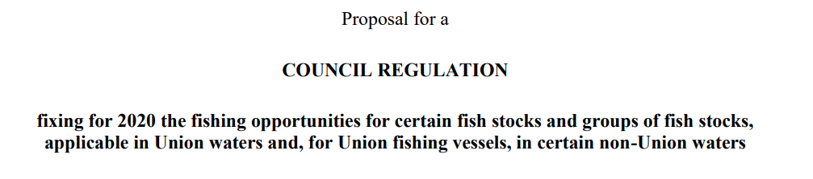
Will be marked as
<meta>
…
<TLCReference xml:id="REG" name="docType"
href="http://publications.europa.eu/resource/authority/resource-type/REG"
showAs="Regulation"/>…
</meta>

<docType refersTo="~REG">COUNCIL REGULATION</docType>

Example with a Council act:
Will be marked as
<meta>
…
<TLCReference xml:id="DEC" name="docType"
href="http://publications.europa.eu/resource/authority/resource-type/DEC"
showAs="DECISION"/>…
</meta>

<docType refersTo="~DEC">COUNCIL DECISION <docNumber>(EU) 2021/1249</docNumber></docType>
Example of a Draft Council decision

<meta>
…
<TLCReference xml:id="DEC" name="docType"
href="http://publications.europa.eu/resource/authority/resource-type/DEC"
showAs="DECISION"/>…
</meta>

<docType refersTo="~DEC">POLITICAL AND SECURITY COMMITTEE DECISION</docType>

<date>
The <date> element is used to mark the date of the act.

<docPurpose>
This element is MANDATORY for <act> or <bill> that are EU acts. It contains the subject of the act.
The <docPurpose> SHOULD have the following inline elements when it contains reference to one or more another act:
- <ref>
Marks the reference to an act mentioned in the subject of the current act.
The mandatory attribute @href contains the ELI identifier of that act.
- <mref>
The fragment of the <docPurpose> that is common to multiple references to an act.

Examples of <longTitle>
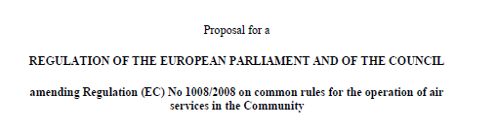

<meta>
<TLCReference xml:id="REG" name="docType"
href="http://publications.europa.eu/resource/authority/resource-type/REG"
showAs="Regulation"/>

</meta>
…
<longTitle>
<p><docStage>Proposal for a</docStage>
<docType refersTo="~REG">REGULATION OF THE EUROPEAN PARLIAMENT AND OF THE COUNCIL</docType>
<docPurpose>amending <ref href="http://data.europa.eu/eli/reg/2008/1008">Regulation (EC) No 1008/2008 on common rules for the operation of air services in the Community</ref></docPurpose></p>
</longTitle>


should be marked as
<meta>
<TLCReference xml:id="REG" name="docType"
href="http://publications.europa.eu/resource/authority/resource-type/REG"
showAs="Regulation"/>

</meta>
…
<longTitle>
<p><docType refersTo="~REG">REGULATION <docNumber>(EU) 2017/2393</docNumber> OF THE
EUROPEAN PARLIAMENT AND OF THE COUNCIL</docType> of <date date="2017-12-13">13 December 2017</date>
<docPurpose>amending <mref>Regulations <ref href="http://data.europa.eu/eli/reg/2013/1305">(EU) No 1305/2013 on support for rural development by the European Agricultural Fund for Rural Development (EAFRD)</ref>, <ref
href="http://data.europa.eu/eli/reg/2013/1306">(EU) No 1306/2013 on the financing,
management and monitoring of the common agricultural policy</ref>, <ref
href="http://data.europa.eu/eli/reg/2013/1307">(EU) No 1307/2013 establishing rules
for direct payments to farmers under support schemes within the framework of the
common agricultural policy</ref>, <ref href="http://data.europa.eu/eli/reg/2013/1308">(EU) No 1308/2013 establishing a common organisation of the markets in agricultural products</ref> and <ref href="http://data.europa.eu/eli/reg/2014/652">(EU) No 652/2014 laying down provisions for the management of expenditure relating to the food chain, animal
health and animal welfare, and relating to plant health and plant reproductive material</ref></mref></docPurpose></p>
</longTitle>
Example of a Draft Council decision

<meta>
…
<TLCReference xml:id="DEC" name="docType"
href="http://publications.europa.eu/resource/authority/resource-type/DEC"
showAs="DECISION"/>…
</meta>

<docType refersTo="~DEC">POLITICAL AND SECURITY COMMITTEE DECISION</docType>

<container name="eeaRelevance">
This optional container indicates the EEA relevance.
Example
<container name="eeaRelevance">
<p>(Text with EEA relevance)</p>
</container>

<preamble>
The preamble contains the citations, the recitals and the solemn forms that precede and follow them.

<formula>
<formula> is used for the solemn forms. It has a mandatory attribute @name with the following values:
<formula>  value of attribute @name | Description
actingEntity | <formula> at the beginning of the preamble, indicating the acting entities.
enactingFormula | <formula> at the end of the preamble.
Example:
<formula name="actingEntity">
<p>THE EUROPEAN PARLIAMENT AND THE COUNCIL OF THE EUROPEAN UNION,</p>
</formula>

<formula name="enactingFormula">
<p>HAVE ADOPTED THIS REGULATION:</p>
</formula>

<citations>
The <citations> element is a wrapper that groups a sequence of elements <citation> (one occurrence for each citation).
When a citation has the attribute @refersTo with the value"~legalBasis" it is the citation indicating the legal basis of the act.
When the value of the attribute @refersTo is "~legalBasis", the <references> part of the metadata MUST have the following entry with a reference to the legal basis concept in the eurovoc:
<meta>
<TLCReference xml:id="legalBasis" name="contentSubject" href="http://eurovoc.europa.eu/5456" showAs="Legal basis"/>
<meta>

Example:
<citations>
<citation refersTo="~legalBasis">
<p>Having regard to the Treaty on the Functioning
of the European Union, and in particular Article 207(2) thereof,</p>
</citation>
<citation>
<p>Having regard to the proposal from the European Commission,</p>
</citation>
<citation>
<p>After transmission of the draft legislative act to the national Parliaments,</p>
</citation>
<citation>
<p>Acting in accordance with the ordinary legislative procedure<authorialNote marker="1" placement="bottom">...</authorialNote>,</p>
</citation>
</citations>

<recitals>
The element <recitals> is a wrapper that groups all recitals. It can contain an introductory text (generally 'Whereas :'), marked as <intro> and one or more recitals (<recital>).
When there are multiple recitals, each recital is numbered so the element <recital> MUST start with a <num> element and the <num> element cannot be empty.
When there is only one recital, it should not be numbered. In this case, <recital> cannot start with <num>.
Example:
<recitals>
<intro><p>Whereas:</p></intro>
<recital>
<num>(1)</num>
<p>A number of amendments are to be made to Directive 2002/92/EC of the European Parliament and of the Council<authorialNote placement="bottom" marker="3">...</authorialNote>. In the interests of clarity, that Directive should be recast.</p>
</recital>
...
</recitals>

<body>
This element contains the enacting terms of the act or bill.
The normative unit of the enacting terms in the EU legislation is the article, numbered continuously from the beginning of the enacting terms. It is marked with the element <article>.
Above the <article>, higher hierarchical divisions are possible:
- <part>
- <title>
- <chapter>
- <section>
- <subsection>

<article>
In the legal acts of the European Union, an article is composed of numbered or unnumbered paragraphs. These paragraphs MUST be marked with the element <paragraph>.
The sub-elements of <article> MUST only be from the following:

Sub-element of <article> | Description
<num> | Mandatory - Defines the number of the article.
<heading> | Optional – Defines the subject of the article.
<paragraph> | Repeatable - Numbered or unnumbered paragraph.  The numbered paragraph starts with a <num> sub-element.  Numbered paragraphs and unnumbered paragraphs cannot be mixed inside the same article.  When there is only one <paragraph> inside <article>, it should not start with a <num> sub-element.
Example:
<article>
<num>Article 2</num>
<heading>Tariff treatment</heading>
<paragraph>
<num>1.</num>
<content>
<p>Customs duties applied to goods originating in Ecuador on <date date="2014-12-12">12 December 2014</date> shall not be increased and no new customs duties introduced after that date shall be applied to those goods.</p>
</content>
</paragraph>
<paragraph>
<num>2.</num>
<content>
<p>The tariff treatment provided for in paragraph 1 shall be applied without prejudice to any measures taken under Regulations (EC) No 260/2009, (EC) No 597/2009 or (EC) No 1225/2009.</p>
</content>
</paragraph>
</article>

The structure inside the <paragraph> was described in "PART 1 – 2.3.2.2 ”Numbered paragraph” and “unnumbered paragraph” (<paragraph>)".

Articles on definitions and articles with amendments
In the Joint Handbook, a special style is required for the numbering of points in articles on definitions and in amending provisions:
‘By way of exception, in the article on definitions (see point C.7) and in amending provisions (see point C.9.1), the numbering of points starts with Arabic numerals within brackets for the first level and continues with lower-case letters within brackets, small Roman numerals within brackets and indents.’
This information is marked up with the @refersTo pointing to an entry of the references section of the metadata.
Every <article> element, that is an 'article on definition' or an 'article with amending provisions', SHOULD have the @refersTo attribute set with a reference to the corresponding entry in the references section.
The following entries are defined:
Value of @refersTo | Corresponding entry in the references section of metadata
~ART_DEF | <TLCConcept xml:id="ART_DEF" href="http://publications.europa.eu/resource/authority/subdivision-content/ART_DEF" showAs="Article on definitions"/>
~ART_AMEND | <TLCConcept xml:id="ART_AMEND" href="http://publications.europa.eu/resource/authority/subdivision-content/ART_AMEND" showAs="Article with amending provisions"/>
Example
<article refersTo="~ART_DEF">
<num>Article 1</num> <heading>Definitions</heading>
…
</article>

<part><title><chapter><section><subsection>
As all elements representing an higher subdivision of text have the same structure, they are grouped in this section.
These elements contain:
- A mandatory text providing the numbering of this structure that is associated with the parent structure,
- the subject of the structure (optional),
- articles or sub-structures (repeatable).
The official documentation prescribes an order for the use of these elements, which in practice has not always been respected in the past.
Example:
<title>
<num>TITLE I</num>
<heading>SCOPE, DEFINITIONS AND GENERAL PRINCIPLES</heading>
<chapter>
<num>CHAPTER I</num>
<heading>Scope and definitions</heading>
<section>
<num>Section 1</num>
<heading>Subject-matter and definitions</heading>
<article>
<num>Article 1</num>
<heading>Subject-matter and scope</heading>
<paragraph>
<num>1.</num>
<content>
<p>This Directive establishes rules on the procedures for procurement by contracting authorities with respect to public contracts as well as design contests, whose value is estimated to be not less than the thresholds laid down in Article 4.</p>
</content>
</paragraph>
<paragraph>
<num>2.</num>
<content>
<p>Procurement within the meaning of this Directive is the acquisition by means of a public contract of works, supplies or services by one or more contracting authorities from economic operators chosen by those contracting authorities, whether or not the works, supplies or services are intended for a public purpose.</p>
</content>
</paragraph>
...
</article>
...
</section>
</chapter>
</title>

<clause>
The body of a Regulation MUST end with a special formula expressing the direct applicability of the Regulation.
This text is outside any <article>, but inside the <body>. It MUST be marked with the element <clause>.

Example:

<clause>
<content>
<p>This Regulation shall be binding in its entirety and directly applicable in all Member States.</p>
</content>
</clause>

<conclusions>
This element marks up the information corresponding to the signature of the document: the location, date and signature.

<references> section of the metadata for the <conclusions>
For the <conclusions>, the <references> part of the metadata has the following entries:
- An optional <TLCLocation> for the location (authority table ‘Place’).
<meta>
…
<TLCLocation xml:id="BEL_BRU" href="http://publications.europa.eu/resource/authority/place/BEL_BRU" showAs="Brussels"/>
…
</meta>
- A mandatory <TLCOrganization> for each institution that signs or will sign the act/bill. For an Ordinary Legislative Procedure, it will be the European Parliament and the Council (authority table ‘Corporate body’ ).
<meta>
…
<TLCOrganization xml:id="CONSIL" href="http://publications.europa.eu/resource/authority/corporate-body/CONSIL" showAs="Council of the European Union"/>
<TLCOrganization xml:id="EP" href="http://publications.europa.eu/resource/authority/corporate-body/EP" showAs="European Parliament"/>
…
</meta>
- a mandatory <TLCRole> for the role of the signatory (authority table ‘Role’)
<meta>
…
<TLCRole xml:id="PRESID" href="http://publications.europa.eu/resource/authority/role/PRESID" showAs="President"/>
…
</meta>

Structure of <conclusions>
The structure of <conclusions> is the following:
- a <p> element contains the text with the location and the date. This element MAY comprise the following inline elements:
Sub-elements of <p> in <conclusion> | Description
<location> | The location of the signature.  The attribute @refersTo points to a <TLCLocation> in the <references> part of the metadata containing the corresponding location.
<date> | The date of the signature.  The attribute @date contains the date in the format YYYY-MM-DD.

- a <block> element with the attribute @name which has the value "signatory". The element <block> MUST contain one or more <signature> elements.
Each <signature> element MUST contain the following sub-elements:

Sub-elements of <signature> | Description
<organization> | The institution of the person who signs the document.  The attribute "refersTo" points to the corresponding TLCOrganization in the <references> part of the metadata.
<role> | The role of the person who signs the document.  The attribute "refersTo" points to the corresponding TLCRole in the <references> part of the metadata.
<person> | The name of the person who signs the document.  The attribute "refersTo" remains empty in this version of AKN4EU.

Example:
<conclusions>
<p>Done at <location refersTo="~BEL_BRU">Brussels</location>, <date date="2014-12-18">18 December 2014</date>.</p>
<block name="signatory">
<signature>
<organization refersTo="~EP">For the European Parliament</organization>
<role refersTo="~PRESID">The President</role>
<person refersTo="">M. SCHULZ</person>
</signature>
...
</block>
</conclusions>

Example 2

<meta>
<TLCOrganization xml:id="CMT_PSC"
href="http://publications.europa.eu/resource/authority/corporate-body/CMT_PSC"
showAs="Political and Security Committee"/>
<TLCRole xml:id="CHAIR"
href="http://publications.europa.eu/resource/authority/role/CHAIR"
showAs="Chairman"/>
</meta>
…
<conclusions>
<p>Done at <location refersTo="~BEL_BRU">Brussels</location>, </p>
<block name="signatory">
<signature>
<organization refersTo="~CMT_PSC">For the Political and Security Committee</organization>
<role refersTo="~CHAIR">The Chairperson</role>
<person refersTo=""></person>
</signature>
...
</block>
</conclusions>

<attachments>
This section is used to make the link in the <bill> or <act> to its annex(es)

<attachment> for “annex”
For each annex, there MUST exist an <attachment> element containing only a <documentRef> element.
The <documentRef> has as attributes:
- A mandatory @href attribute containing the path to the file containing the annex;
- the content of the <container name=" headerOfAnnex ">/<block="num"> element of the corresponding annex
Example
<attachment>
<documentRef href="….xml"
showAs="ANNEX I"/>
</attachment>

<attachment> for “Table of annex”
If annexes are preceded by a “table of annexes”, there MUST exist an <attachment> element for this.
See AKN4EU PART 1 – 1.1.4 The table of annexes for the mark-up inside this <attachment>.

<attachment> for “attachment”
For each legal act attached to this act, there MUST exist an <attachment> element containing a <documentRef> element eventually preceded by a <num> element.
This <attachment>
- MUST have an attribute @refersTo pointing to a <TLCReference name=”doctype”> for the ‘ATTACHMENT’ entry of the authority table ‘resource type’
- CAN have an element <num> if the word “ANNEX” is used in the text to introduce the attachment
- Must have a <documentRef> that reference the AKN4EU file with the content of the “attachment”.
The <documentRef> has as attributes:
- A mandatory @href attribute containing the path to the file containing the attachment;
- the content of the <longTitle>/<doctype> element of the corresponding attachment
Example
<meta>
…
<TLCReference xml:id="ATTACHMENT" name="docType"
href="http://publications.europa.eu/resource/authority/resource-type/ATTACHMENT"
showAs="Attachment"/>
…
</meta>
<attachment refersTo=”~ATTACHMENT”>
<num>ANNEX</num>
<documentRef href="….xml" showAs="Decision …"/>
</attachment>
Or, if the word “ANNEX” is not present:
<meta>
…
<TLCReference xml:id="ATTACHMENT" name="docType"
href="http://publications.europa.eu/resource/authority/resource-type/ATTACHMENT"
showAs="Attachment"/>
…
</meta>
<attachment refersTo=”~ATTACHMENT”>
<documentRef href="….xml" showAs="Decision …"/>
</attachment>

Annex
Annexes are used to present material separately from the body of the enacting terms, because it is either voluminous or technical or both. Annexes are an integral part of an act. When there are multiple annexes, they are numbered in the order of appearance.
The annexes are marked up with the element <doc>.
<doc> has a mandatory attribute @name. The value of this attribute is:
Value of attribute @name | Description
ANNEX | This is the generic code issued from the Authority table ‘Resource type’ available on OP EU Vocabularies website.

Overall organization
<doc name="ANNEX"> has the following structure:
- <meta> mandatory (metadata)
- <preface> mandatory
- <mainBody> mandatory
- <attachments> mandatory if annex has annex(es)

<meta>
The following metadata are required:
- The metadata required by AKN4EU (see AKN4EU PART1 – section 9.5)
The <FRBRprescriptive> metadata MUST be set to "true".
- In <references>, a <TLCReference name="docType"> MUST exist, with the information on the entry in the authority table "resource-type" corresponding to the value of the @name attribute of the <doc> (the value of the attribute @name MUST be the authority code)
Example
<doc name="ANNEX">
<meta>
...
<references source="~...">
...
<TLCReference xml:id="REG" name="docType"
href="http://publications.europa.eu/resource/authority/resource-type/ANNEX"
showAs="Annex"/>
...
</references>
</meta>
...
</act>

<preface>
The preface contains the title of annexes.
The title of an annex is more similar to the title of a chapter or a section than to the title of an act: it contains the numbering of the annex inside the act/bill and the subject of the annex. Therefore, instead of the element <longTitle>, a specific <container> is used.
<container> has a mandatory attribute @name. The value of this attribute is:
Value of attribute @name | Description
headerOfAnnex | The title of the annex.

The <container> MUST be composed of elements <block>. The <block> has a mandatory attribute @name. The value of this attribute is:
Value of attribute @name | Description
num | Mandatory.  The numbering of the annex in the act.  If there is only one annex, only the word "ANNEX", without number.  Else, the word ANNEX with a number.
heading | Optional.  The subject of the annex.

Example:
<preface>
<container name="headerOfAnnex">
<block name="num">ANNEX I</block>
<block name="heading">TYPES OF ACTIONS</block>
</container>
</preface>

<mainBody>
Currently, annexes can have various structures. They differ structurally from the body of the act because they are not composed of articles.
The structure of annexes can be composed of 3 levels of elements:
- The core structures allowed are:
  - independent points;
  - unnumbered paragraphs;
  - articles.
All these structures are optional: an annex can be composed:
- of unnumbered paragraphs, or
- of independent points, or
- of a sequence of articles, or
- of unnumbered paragraphs followed by independent points
“Independent subject(s)”(“crossheading”) are also allowed (<block name=”crossheading”>) as child of <mainBody> .
- The core structures can be grouped into named high-level structures, as in the enacting terms of the act: part, title, chapter, section.
- A lower level structures, grouping all structures available inside the core structures.

High level structures
As in the enacting terms of acts, the following elements are available to represent the high-level structures in annexes:
- <part>
- <title>
- <chapter>
- <section>
Example:
- <chapter>
<num>CHAPTER I</num>
<heading>Subject matter for the training of staff performing official controls and other official activities</heading>
- …
- </chapter>

The possible content of the named high-level structures is described in PART 1 – 2.3.1. Core structures

Article (<article>)
Some annexes are composed of <article>.
See “AKN4EU PART 1 – section 2.3.2.1 Article <article>” on the way to mark “article”.

Independent points: element <level>
See ‘PART 1 – 2.3.2.3 independent point (<level>)’ on the way to mark “independent points”;

Unnumbered paragraphs
See ‘PART 1 – 2.3.2.2 “Numbered paragraph” and “unnumbered paragraph” (<paragraph>)’ on the way to mark “unnumbered paragraph”;
!
In annex of EU acts, “numbered paragraph” is forbidden except as a subdivision of an <article>;
Only “independent point”(<level>) (and <article>) can be used as numbered core structure of an annex.

“crossheading”
Use the mark-up <block name=”crossheading”> when the “crossHeading” is child of <mainBody>.
Use the mark-up <crossheading> when the “crossheading” is inside another subdivision.

Low level structures
All the low level structures are acceptable in annexes

Inside the core structure <article>
See PART 1 – 2.3.2.1 for the acceptable structures inside an <article>

Inside the core structure <paragraph>
See PART 1 – 2.3.2.2 for the acceptable structures inside “unnumbered paragraph”

Inside the core structure <level>
See PART 1 – 2.3.2.3 for the acceptable structures inside a <level>

<attachments>

annex of an annex
For each embedded annex, there MUST exist inside <attachments>, an <attachment> element containing only a <documentRef> element.
The <documentRef> has as attributes:
- A mandatory @href attribute containing the path to the file containing the embedded annex;
- the content of the <container name="headerOfAnnex">/<block="num"> element of the corresponding annex
Example
<attachment>
<documentRef href="….xml"
showAs="Appendix"/>
</attachment>

International Agreement

International Agreements : use cases for AKN4EU
The structure of an International agreement, according to the CoV is the following
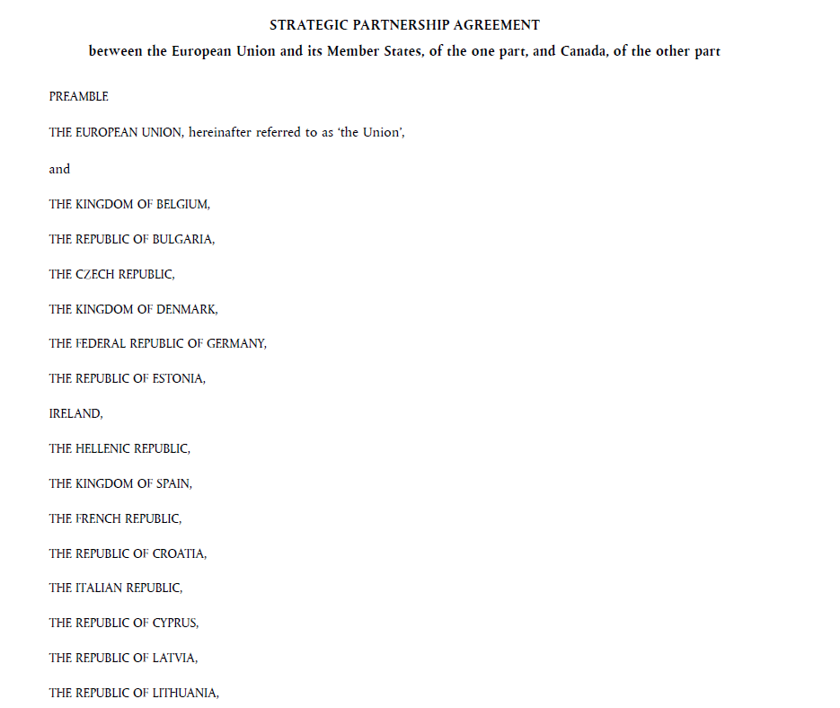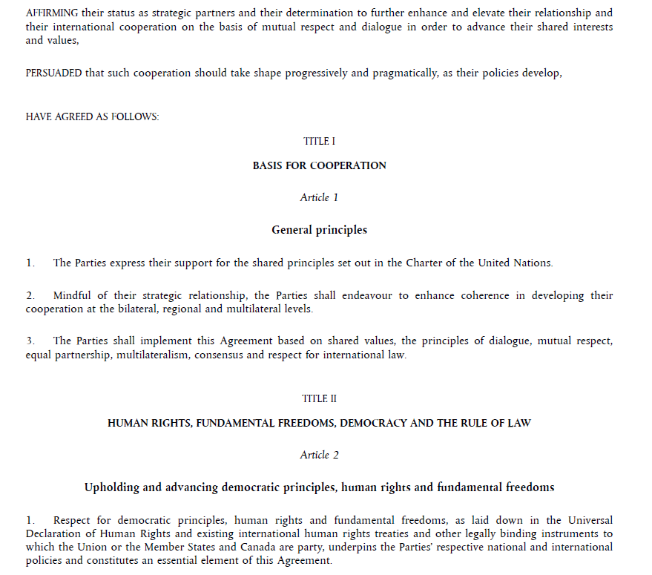
article
Enacting terms
recitals
Title of the document
Acting entity
preamble
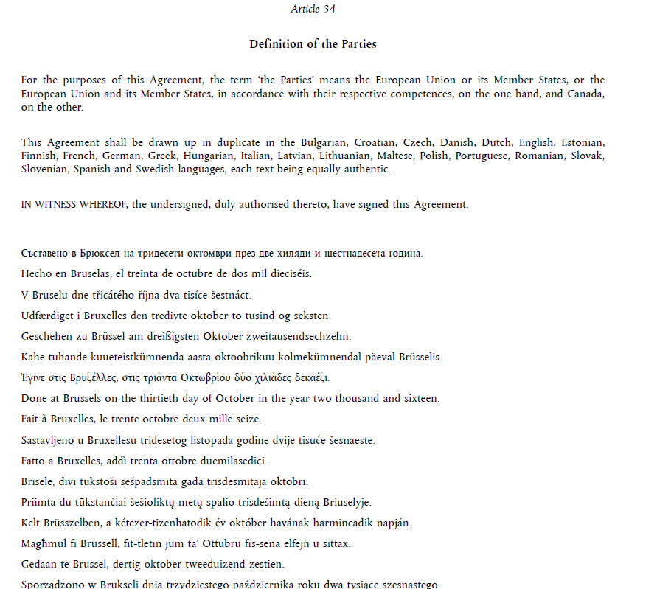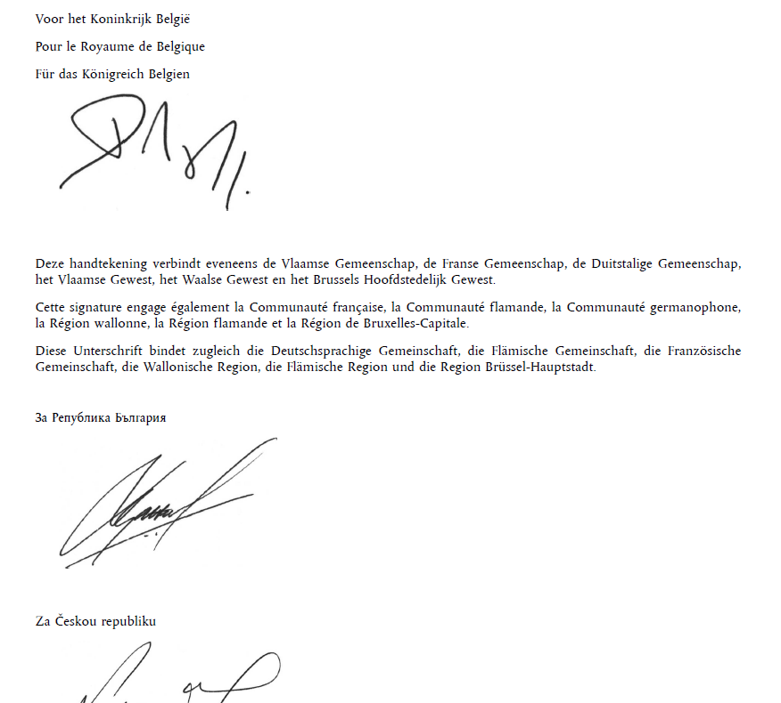
signatories
signature
Place and date

AKN4EU mark-up of the International Agreement: overall structure
The main part of an International Agreement, containing the title of the document, the preamble, the enacting terms and the signatures is in one AKN4EU file. It is marked as an <act> or a <bill> (see after).
An International Agreement can contain one or more annex(es). In this case
- For each annex, it must exist inside the <attachments> section of the <act> or the <bill> one <attachment> element;
- The content of each annex MUST be in a specific AKN4EU file;
- Each annex is marked with the element <doc>.
<act> or <bill>

The AKN4EU mark-up of the main part of the International Agreement

<act> or <bill>
Akoma Ntoso uses two elements to mark up a legal text:
- <act>, for the final version that is published in the Official Journal;
- <bill>, for the main part of any draft version of the legal text during the legislative process.
Accordingly, in AKN4EU,
- International Agreement, when published in the Official Journal, are marked as <act>
- A draft version of what may become, at the end of the legislative procedure, an International Agreement, is marked as a <bill>.

@name attribute
<act> or <bill> MUST have a @name attribute, used in AKN4EU to define the type of act.
In AKN4EU, the value of this attribute MUST be the code of an entry of the Named Authority List ‘Resource type’ (https://publications.europa.eu/en/web/eu-vocabularies/at-dataset/-/resource/dataset/resource-type).
The following values for the attribute @name are used:
Value of the attribute @name  for <act> or <bill> | Description
"AGREE_INTERNATION" | - International Agreement  - Any draft version of a International Agreement.

Overall organization
<act> and <bill> for International Agreement have the following structure:
- <meta> mandatory (metadata)
- <preface> mandatory
- <preamble> mandatory
- <body> mandatory
- <conclusions> mandatory
- <attachments> mandatory if the International Agreement has annex(es)

<meta>
The following metadata are required:
- The metadata required by AKN4EU (see AKN4EU PART1 – section 9.5)
The <FRBRprescriptive> metadata MUST be set to "true".
- In <references>, a <TLCReference name="docType"> MUST exist, with the information on the entry in the authority table "resource-type" corresponding to the value of the @name attribute of the <act> or <bill> (the value of the attribute @name MUST be the authority code)
Example
<act name="AGREE_INTERNATION">
<meta>
...
<references source="~...">
...
<TLCReference xml:id="AGREE_INTERNATION" name="docType"
href="http://publications.europa.eu/resource/authority/resource-type/AGREE_INTERNATION"
showAs="International agreement"/>
...
</references>
</meta>
...
</act>

<preface>
The <preface> can contain the following containers:

<longTitle>
The <longTitle> is used to mark the title of the document.
The <longTitle> MUST contain only one <p> that can contain the following elements:
- <docType>
- <docPurpose>

<docType>
<docType> MUST be used to mark the line containing the type of the <act> or <bill>.
The mandatory attribute @refersTo points to the corresponding <TLCReference name="docType">.
Example
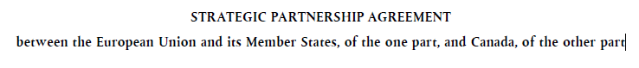
Will be marked as
<meta>
…
<TLCReference xml:id="AGREE_INTERNATION" name="docType"
href="http://publications.europa.eu/resource/authority/resource-type/AGREE_INTERNATION"
showAs="International agreement"/>
</meta>
…
<longTitle>
<p><docType refersTo="~AGREE_INTERNATION">STRATEGIC PARTNERSHIP AGREEMENT</docType>
<docPurpose>between the European Union and its Member States, of the one part, and Canada, of the other part</docPurpose></p>
</longTitle>

<docPurpose>
This element is MANDATORY for <act> or <bill> that are International agreements. It contains the subject of the act.

<preamble>
The preamble contains the citations, the recitals and the solemn forms that precede and follow them.

<heading>
The preamble can have a heading.
If this is the case, the title MUST be marked up with a <block> element. This element has a mandatory attribute @name. The value of this attribute MUST be:
Value of attribute @name | Description
heading | This value indicates that the block is, in fact, a subject and is used when the <heading> element is not available.

Example:
<preamble>
<block name="heading">PREAMBLE</block>
…
</preamble>
The preamble contains the recitals and the solemn forms that precede and follow them.
The mark-up for these structures is the following:
The two <formula MUST be used:
- @name = "actingEntity"at the beginning of the preamble
Each line of this formula is in a specific <p>
Example
<formula name="actingEntity">
<p>THE EUROPEAN UNION, hereinafter referred to as ‘the Union’,</p>
<p>and</p>
<p>THE KINGDOM OF BELGIUM,</p>
<p>THE REPUBLIC OF BULGARIA,</p>
<p>THE CZECH REPUBLIC,</p>
…
<p>of the one part, and</p>
<p> CANADA,</p>
<p>of the other part,</p>
<p>hereinafter jointly referred to as ‘the Parties’,</p>

- @name = "enactingFormula"
at the end of the preamble
Example
<formula name="enactingFormula">
<p>HAVE AGREED AS FOLLOWS:</p>
</formula>

<recitals>
The element <recitals> is a wrapper that groups all recitals. The introductory text is optional.
Each recital MUST be in an element <recital>. The recitals can be without numbering (so <num> element is not mandatory).
Example:
<recitals>
<recital>
<p>INSPIRED BY the long-standing friendship forged between the people of Europe and Canada through their extensive historical, cultural, political and economic links,</p>
</recital>
…
</recitals>

<body>
Similar to the enacting terms of EU acts.
NB: Subparagraph with points can be without introductory part.

<conclusions>
The conclusions can be as follows:
- first, a sequence of paragraphs
- the place and date in the languages of all the parties
- the signatory.

Place and date
Each linguistic variant of the place and date MUST be marked with a <p> element with the @xml:lang attribute with, as value, the two-letter code of the language of the content.

In each linguistic variant, the <location> identifies the place of the signature and the <date> element identifies the date of the signature.
Example:
<p xml:lang="bg">Съставено в <location refersTo="~BEL_BRU">Брюксел</location> на <date date="2016-10-30">тридесети октомври през две хиляди и шестнадесета година</date>.</p>
<p xml:lang="es">Hecho en <location refersTo="~BEL_BRU">Bruselas</location>, el <date date="2016-10-30">treinta de octubre de dos mil dieciséis</date>.</p>
…

For each value of the @xml:lang attribute, a corresponding <TLCReference name="language"> MUST be created in the <references> section of the metadata.
For each value of the @refersTo attribute of the <location> element, a corresponding <TLCLocation> MUST be created in the <references> section of the metadata.
For example:
<meta>
…
<TLCReference name="language"
href="http://publications.europa.eu/resource/authority/language/BUL" showAs="bg"/>
<TLCReference name="language"
href="http://publications.europa.eu/resource/authority/language/SPA" showAs="es"/>
<TLCLocation xml:id="BEL_BRU"
href="http://publications.europa.eu/resource/authority/place/BEL_BRU"
showAs="Brussels"/>
…
</meta>

Signatory

The signatory MUST be marked with a <block> element. The mandatory @name attribute MUST have the value "signatory". It contains one or more <signature> elements.
For the International Agreement each <signature> element MUST contain the following sub-elements:
Sub-elements of <signature> | Description
<organization> | The <organization> to identify the party of the person who signs the document.  The attribute @refersTo MUST point to the corresponding <TLCOrganization> in the <references> part of the metadata.  In case of the International Agreement, the <TLCOrganization> CAN be an entry of the Authority table ‘Country’ or of the Authority table 'Corporate body'.  The information is expressed in an official language of the country that the signatory represents. Sometimes, the information can thus be expressed in multiple linguistic versions.  In any case, it is not always the language of this Expression and this information remains in the original language.  For this reason, there can be multiple occurrences of <organization> in one <signature>, one for each specific linguistic version.  The following rules apply:  - If there are multiple occurrences of <organization> in one <signature>, each <organization> of a same <signature> MUST have the same @refersTo value. It means that it MUST point to the same <TLCOrganization> in the references part of the metadata.  - When there are multiple occurrences of <organization>, each occurrence MUST have an @xml:lang attribute with a different value.  A corresponding <TLCReference name="language"> MUST be created.
<person> | The <person> element with an empty @refersTo. This element will contain the image of the handwritten signature.
<remark> | Additional information after the handwritten signature.  For example:  <remark xml:lang="fr">Cette signature engage également la Communauté française, la Communauté flamande, la Communauté germanophone, la Région wallonne, la Région flamande et la Région de Bruxelles-Capitale.  </remark>
Example
<meta>
…
<TLCOrganization xml:id="BEL"
href="http://publications.europa.eu/resource/authority/countries/BEL" showAs="Kingdom of Belgium"/>
<TLCReference name="language"
href="http://publications.europa.eu/resource/authority/language/NLD" showAs="nl"/>
<TLCReference name="language"
href="http://publications.europa.eu/resource/authority/language/FRA" showAs="fr"/>
<TLCReference name="language"
href="http://publications.europa.eu/resource/authority/language/DEU" showAs="de"/>
…
</meta>
<block name="signatory">
<signature>
<organization refersTo="~BEL" xml:lang="nl">Voor het Koninkrijk België</organization>
<organization refersTo="~BEL" xml:lang="fr">Pour le Royaume de Belgique</organization>
<organization refersTo="~BEL" xml:lang="de">Für das Königreich Belgien</organization>
<person refersTo="">
<img src="L_2016329EN.01006001.tif"/>
</person>
<remark xml:lang="nl">Deze handtekening verbindt eveneens de Vlaamse Gemeenschap, de Franse Gemeenschap, de Duitstalige Gemeenschap, het Vlaamse Gewest, het Waalse Gewest en het Brussels Hoofdstedelijk Gewest.</remark>
<remark xml:lang="fr">Cette signature engage également la Communauté française, la Communauté flamande, la Communauté germanophone, la Région wallonne, la Région flamande et la Région de Bruxelles-Capitale.</remark>
<remark xml:lang="de">Diese Unterschrift bindet zugleich die Deutschsprachige Gemeinschaft, die Flämische Gemeinschaft, die Französische Gemeinschaft, die Wallonische Region, die Flämische Region und die Region Brüssel-Hauptstadt.</remark>
</signature>…
</block>

<attachments>
This section is used to make the link in the <bill> or <act> to its annex(es)

<attachment>
For each annex, it MUST exist a <attachment> element containing only a <documentRef> element.
The <documentRef> has as attributes:
- A mandatory @href attribute containing the path to the file containing the annex;
- the content of the <container name=" headerOfAnnex ">/<block="num"> element of the corresponding annex
Example
<component>
<documentRef href="….xml"
showAs="ANNEX I"/>
</component>

The AKN4EU mark-up of the Annex
Annexes are used to present material separately from the body of the enacting terms, because it is either voluminous or technical or both. Annexes are an integral part of an act. When there are multiple annexes, they are numbered in the order of appearance.
The annexes are marked up with the element <doc>.
<doc> has a mandatory attribute @name. The value of this attribute is:
Value of attribute @name | Description
ANNEX | This is the generic code issued from the Authority table ‘Resource type’ available on OP EU Vocabularies website.

Overall organization
<doc name="ANNEX" has the following structure:
- <meta> mandatory (metadata)
- <preface> mandatory
- <mainBody> mandatory
- <attachments> mandatory if annex has annex(es)

<meta>
The following metadata are required:
- The metadata required by AKN4EU (see AKN4EU PART1 – section 9.5)
The <FRBRprescriptive> metadata MUST be set to "true".
- In <references>, a <TLCReference name="docType"> MUST exist, with the information on the entry in the authority table "resource-type" corresponding to the value of the @name attribute of the <documentCollection> (the value of the attribute @name MUST be the authority code)
Example
<doc name="ANNEX">
<meta>
...
<references source="~...">
...
<TLCReference xml:id="ANNEX" name="docType"
href="http://publications.europa.eu/resource/authority/resource-type/ANNEX"
showAs="Annex"/>
...
</references>
</meta>
...
</act>

<preface>
The preface contains the title of annexes.
The title of an annex is more similar to the title of a chapter or a section than to the title of an act: it contains the numbering of the annex inside the act/bill and the subject of the annex. Therefore, instead of the element <longTitle> a specific <container> is used.
<container> has a mandatory attribute @name. The value of this attribute is:
Value of attribute @name | Description
headerOfAnnex | The title of the annex.

The <container> MUST be composed of elements <block>. The <block> has a mandatory attribute @name. The value of this attribute is:
Value of attribute @name | Description
num | Mandatory.  The numbering of the annex in the act.  If there is only one annex, only the word "ANNEX", without number.  Else, the word ANNEX with a number.
heading | Optional.  The subject of the annex.

Example:
<preface>
<container name="headerOfAnnex">
<block name="num">ANNEX I</block>
<block name="heading">TYPES OF ACTIONS</block>
</container>
</preface>

<mainBody>
Similar to the <mainBody> of the annexes of EU acts.

<attachment>
For each annex of annex, it MUST exist a <attachment> element containing only a <documentRef> element.

Proposal for an act

Proposal for an act : use cases for AKN4EU
The AKN4EU baseline version contains the following use cases for the Proposal for an act:
- Proposal for a decision
- Proposal for a directive
- Proposal for a regulation
- Proposal for a Implementing Decision
in the context of Legislative/legal procedure.
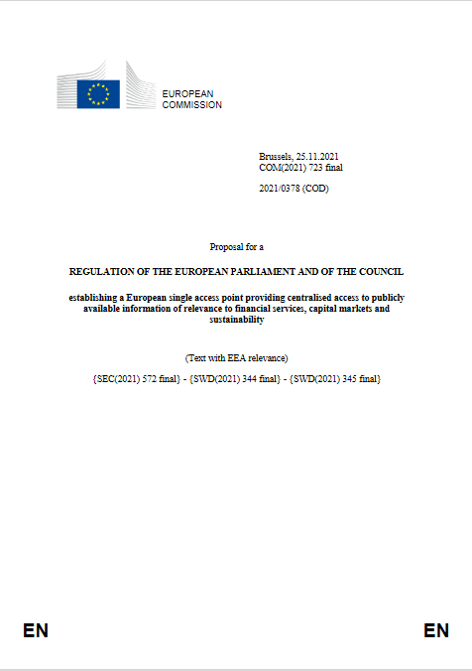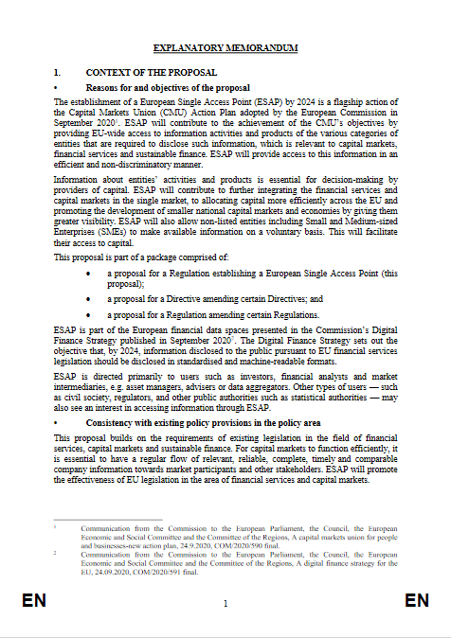
Cover page
Explanatory memorandum
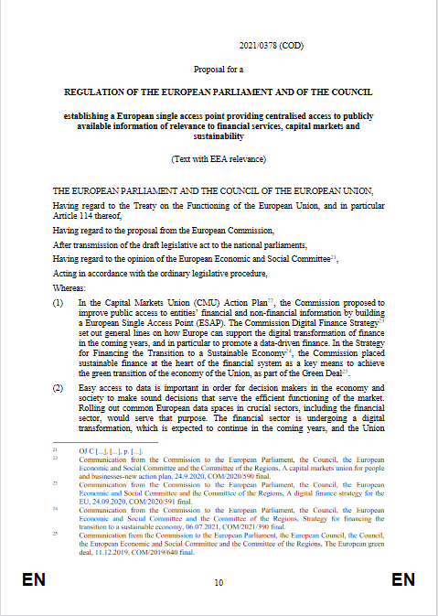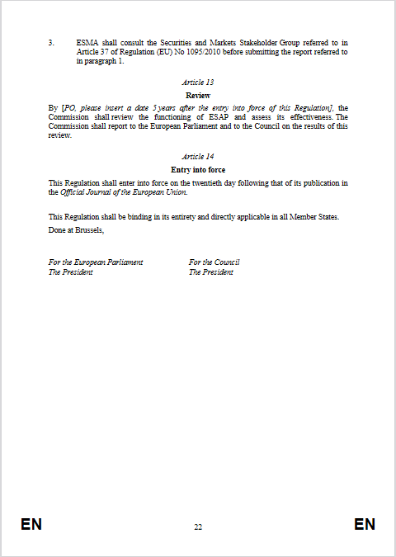
Legal text (Decision, Directive or Regulation
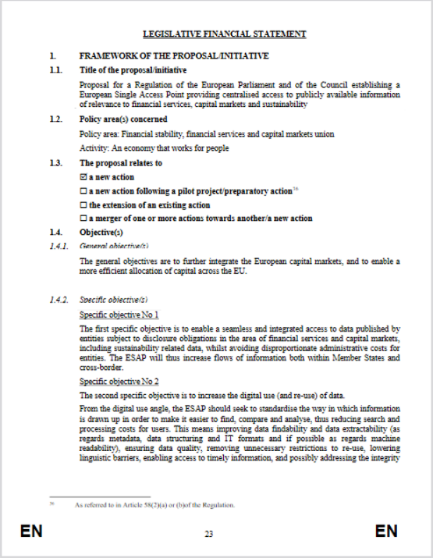
Legislative Financial and DigitalStatement
(or Legislative Financial Statement)
For some Proposals, a document can be attached to the Legal text. It is not really an annex of the Legal text, as it will not be published in the Official Journal as an annex.
In this case, the layout is the following:
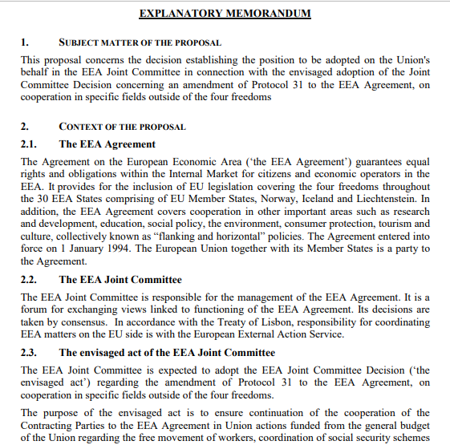
Attachment
(Decision)
Cover page
Explanatory memorandum
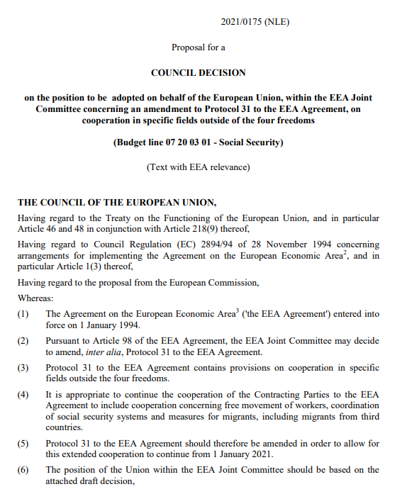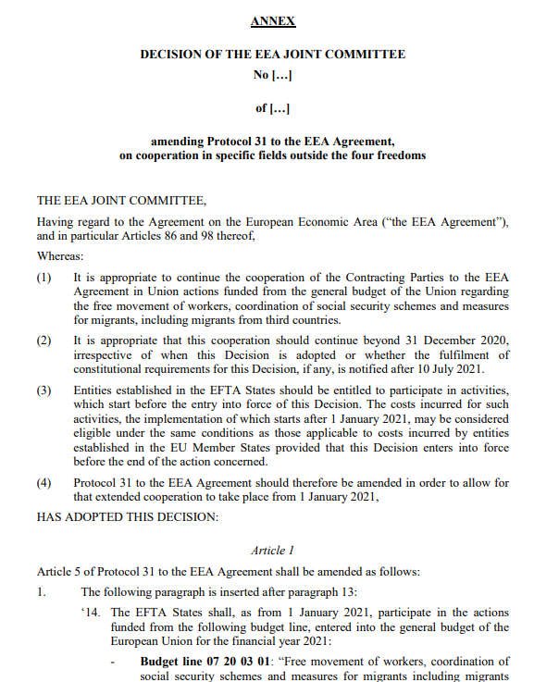
Legal text (Decision)

AKN4EU mark-up of the Proposal for an act: overall structure
The Proposals for an act (Proposal for a decision, Proposal for a directive or Proposal for a Regulation) follows the standard AKN4EU model of a document:
- The entry point (main.xml of a .leg package) is a <documentCollection>.
- The <documentCollection> contains the information of the cover page.
- The <documentCollection> has, as subdocument:
- an optional Explanatory Memorandum
- a mandatory Legal Text that is a Decision, a Directive, a Regulation or an Implementing Decision.
- An optional Financial Statement or Financial and Digital Statement
For each subdocument, the <documentCollection> contains, inside the <collectionBody>, one <component> element.
- The content of each subdocument is in a specific file
Document type of the subdocuments
- For the Explanatory Memorandum, the file MUST have as document type:
<doc name="EXPL_MEMORANDUM">
For the legal text
The file MUST have as document type: <bill>.
The @name attribute MUST have as value "DEC", "DIR", "REG" or DEC_IMPL depending on the type of the legal text.
See AKN4EU PART 2 – 2.1 EU acts – section 2 AKN4EU mark-up of the EU acts: overall structure for the components of an EU act.
- For the Legislative Financial and Digital Statement, the file MUST have as document type:
<doc name="STAT_DIGIT_FINANC_LEGIS">.
- For the Legislative Financial Statement, the file MUST have as document type:
<doc name="STAT_FINANC_LEGIS">.

The normal structure for a Proposal for an act is the following:

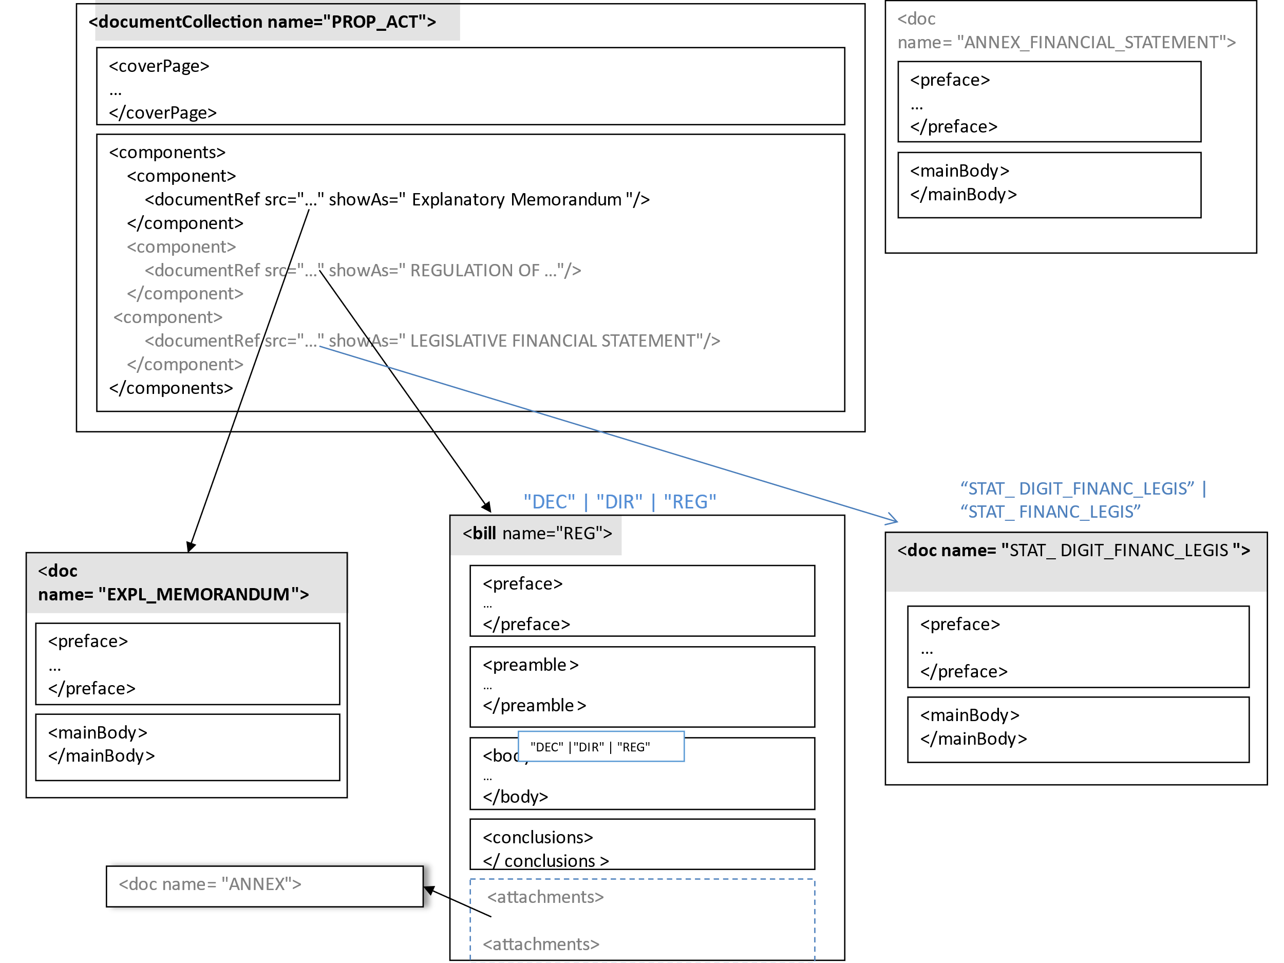

The mark-up of the <documentCollection>

@name attribute
The attribute @name MUST have the value "PROP_ACT ", corresponding to the code of the authority table "resource-type" for this type of document.

Overall organization
This document type has the following structure:
- <meta> mandatory
- <coverPage> mandatory
- <collectionBody> mandatory

<meta>
The following metadata are needed:
- The metadata required by AKN4EU (see AKN4EU PART1 – section 9.5)
The @value of <FRBRprescriptive> is set to “false”
- In <references>, a <TLCReference name="docType"> MUST exist, with the information on the entry in the authority table "resource-type" corresponding to the value of the @name attribute of the <documentCollection> (the value of the attribute @name is the authority code)
Example
<documentCollection name="PROP_ACT">
<meta>
...
<references source="~...">
...
<TLCReference xml:id="PROP_ACT" name="docType"
href="http://publications.europa.eu/resource/authority/resource-type/PROP_ACT"
showAs="Proposal for an act"/>
...
</references>
</meta>
...
</documentCollection>
- In <references>, a <TLCReference name="procedureReference"> MUST exist, if the document is associated to a legislative/legal procedure. As forth indication of the @shortForm attribute, the step inside the legislative/legal procedure CAN be indicated if the information is known and meaningful.
Example
<TLCReference xml:id="procedure_2011_458" name="procedureReference"
href="http://eur-lex.europa.eu/procedure/EN/2011_458" showAs="2011/0458 (COD)"
shortForm="2011/458/COD/RDG1"/>

<TLCReference xml:id="_procedure_2020_165" name="procedureReference"
href="http://eur-lex.europa.eu/procedure/EN/2020_165"
showAs="2020/0165 (CNS)" shortForm="2020/165/CNS"/>

- A corresponding <TLCProcess> CAN exist to make a explicit link between the step inside the legislative/legal procedure and the corresponding entry in the authority table:
<TLCProcess xml:id="RDG1" href="http://publications.europa.eu/resource/authority/procedure-phase/RDG1" showAs="First reading"/>

<coverPage>
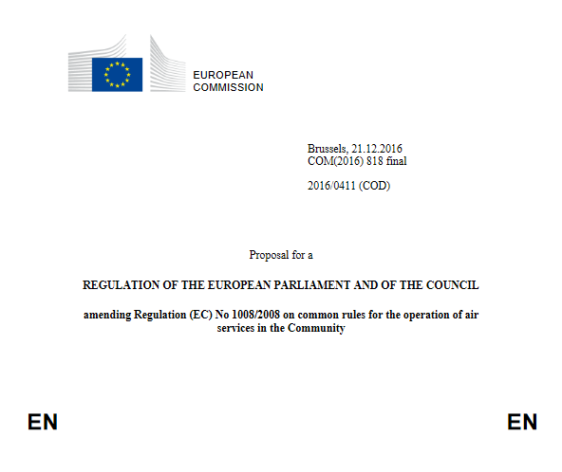
container name="mainDocLanguage"
container name="procedureIdentifier"

container name="actingEntity"

container name="logo"

container name="mainDoc"

longTitle

The <coverPage> CAN contain the following containers:

<container name="logo">
No specific mark-up
Example
<container name="logo">
<p><img src="COM.png"/></p>
</container>

<container name="actingEntity">
It contains one <p>. The <p> contains <organization> with the mandatory @refersTo attribute pointing to an <TLCOrganization> element in the <references> part of the metadata.
If <container name=”logo”> exists, <container name=”actingEntity” MUST also be present.
Example


<meta>
<TLCOrganization xml:id="COM"
href="http://publications.europa.eu/resource/authority/corporate-body/COM"
showAs="European Commission"/>
</meta>
…
<container name="logo">
<p><img src="….png"/></p>
</container>
<container name="actingEntity">
<p><organization refersTo="~COM">EUROPEAN COMMISSION</organization></p>
</container>

For joint act, a double header is foreseen on the cover page.
In this case, there are two <container name=”actingEntity”> (a second <container name=”logo”> can also be present).
The sequence of the <container> is the sequence of the display, from left to right
For Example:

Will be marked as:
<meta>
<TLCOrganization xml:id="COM"
href="http://publications.europa.eu/resource/authority/corporate-body/COM"
showAs="European Commission"/>
<TLCOrganization xml:id="HRUFASP"
href="http://publications.europa.eu/resource/authority/corporate-body/HRUFASP"
showAs="High Representative of the Union"/>
</meta>
…
<container name="logo">
<p><img src="….png"/></p>
</container>
<container name="actingEntity">
<p><organization refersTo="~COM">EUROPEAN COMMISSION</organization></p>
</container>
<container name="actingEntity">
<p><organization refersTo="~HRUFASP">High Representative of the Union for Foreign Affairs and Security</organization></p>
</container>

<container name="mainDoc">
This container contains the information related to the document itself: location, date and the document reference.
- The place and date is marked with a <block name=”placeAndDate”> element. Inside,
  - the place MUST be in a <location> element with the @refersTo attribute pointing to the corresponding entry in the <references> part of the metadata.
  - The date MUST be in a <date> element with a mandatory @date attribute.
- The reference of the document is marked with a <block name="reference">.
The reference itself MUST be inside a <docNumber> element with a mandatory @refersTo attribute pointing to the corresponding <TLCReference name="identifier"> .
The information on the version MUST be inside the <docNumber> in an <inline name="version"> element
Before finalization, the document can be identified with a Commission internal identifier
When finalized, the reference is an official identifier like a COM number.
Example: Proposal with a reference that is a COM_NUMBER
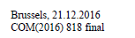
<meta>
<TLCLocation xml:id="BEL_BRU"
href="http://publications.europa.eu/resource/authority/place/BEL_BRU" showAs="Brussels"/>
<TLCReference xml:id="prs3y" name="identifier" href="http://publications.europa.eu/resource/authority/document-identifier-format/COM_NUMBER" showAs="COM(2012) 818" shortForm="COM/2012/818"/>
</meta>
<container name="mainDoc">
<block name="placeAndDate"><location refersTo="~BEL_BRU">Brussels</location>, <date date="2012-09-28">28.09.2012</date> </block>
<block name="reference"> <docNumber refersTo="~prs3y">COM(2012) 818 <inline name="version" >final</inline></docNumber></block>
</container>
The Join Proposal has also a specific reference number (for example JOIN(2022) 19) but the <TLCReference name=”identifier”> refers to the “COM number” in the authority table “document-identifier-format”.
Example
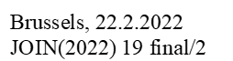
will be marked as
<meta>
<TLCLocation xml:id="BEL_BRU"
href="http://publications.europa.eu/resource/authority/place/BEL_BRU" showAs="Brussels"/>
<TLCReference xml:id="prs3y" name="identifier" href="http://publications.europa.eu/resource/authority/document-identifier-format/COM_NUMBER" showAs="JOIN(2022) 19" shortForm="JOIN/2022/19"/>
</meta>
<container name="mainDoc">
<block name="placeAndDate"><location refersTo="~BEL_BRU">Brussels</location>, <date date="2022-02-22">22.2.2022</date> </block>
<block name="reference"> <docNumber refersTo="~prs3y">JOIN(2022) 19 <inline name="version" >final/2</inline></docNumber></block>
</container>

Example: Proposal not finalised, with an internal reference
<meta>
<TLCReference xml:id="avts98y" name="identifier" href="http://publications.europa.eu/resource/authority/document-identifier-format/ COM_NUMBER_INTERNAL" showAs="ckylbnre200dy396bvhp2a1hk" shortForm="ckylbnre200dy396bvhp2a1hk"/>
</meta>
…
<container name="mainDoc">
…
<block name="reference"><docNumber refersTo="~avts98y">ckylbnre200dy396bvhp2a1hk</docNumber> </block>
…
</container>

<container name="procedureIdentifier">
This container contains the identifier and the type of the legislative procedure.
The container contains a <p> element. The identifier and the type of the legislative procedure MUST be in a <docketNumber> element. The <docketNumber> element MUST have a @refersTo attribute that points to the corresponding <TLCReference name="procedureReference">
Example

Will be marked as following
<meta>
<TLCReference xml:id="procedure_2016_411" name="procedureReference"
href="http://eur-lex.europa.eu/procedure/EN/2016_411"
showAs="2016/0411(COD)" shortForm="2016/411/COD/RDG1"/>
</references>
</meta>
...
<container name="procedureIdentifier">
<p><docketNumber refersTo="~procedure_2016_411">2016/0411 (COD)</docketNumber></p>
</container>

<container name="corrigendum"> and <container name=”addendum”>
When a new version of a document has to be corrected after sending to external partners, this new version has, in the cover page a box “corrigendum” with the reference to the document modified, the explanation of the correction and the language affected. When an addendum is done, the cover page has a box “addendum”
The <container name=”corrigendum”> and the <container name=”addendum”> have a similar structure. Both contains multiple <p>.
Inside, the inline elements are available:
- <affectedDocument> with inside, a <docNumber> with <inline name=”version”>, for the version and <date> for the <date> of the document modified
<affectedDocument> has a mandatory @href attribute that contains the ELI URI (or the CELEX URI) of the preparatory document that is corrected.
<docNumber> has a mandatory @refersTo attribute pointing to an entry <TLCReference name=”identifier”>
- <inline name=”language”> for each language that is affected, when only some linguistic variant are affected. Each <inline name=”language”> MUST have a @refersTo attribute pointing to the corresponding <TLCReference name=”language”>.
<inline name=”correctionInfo”> for the information on the correction
Example:
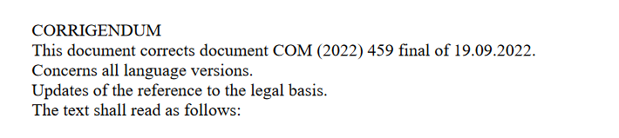
Will be marked as
<container name="corrigendum">
<p>CORRIGENDUM</p>
<p>This document corrects document <affectedDocument href=”http://data.europa.eu/eli/dl/proc/2022/278/COD/doc/com/COM_(2022)_459/final”><docNumber>COM (2022) 459 <inline name=”version”>final</inline></docNumber> of <date date=”2022-09-19”>19.09.2022</date></affectedDocument></p>
<p>Concerns all language versions.</p>
<p><inline name="correctionInfo">Updates of the reference to the legal basis.</inline></p>
<p>The text should read as follows:</p>
</container>

<container name="authenticLanguages">
For acts entering into force by their notification, only the language versions in which the act is notified are authentic.
This information is inside a <container name=”authenticLanguages”>.
Each language inside MUST be identified with an <inline name="language"> element.
The <inline> element for the language MUST have an attribute @refersTo pointing to the corresponding <TLCReference name=”language”> metadata.
Example:

<meta>
…
<TLCReference xml:id=”en” href="http://publications.europa.eu/resource/authority/language/ENG" name="language" showAs="en"/>
…
</meta>
<container name="authenticLanguages">
<p>Only the <inline name="language" refersTo="~en">English</inline> language is authentic</p>
</container>

<container name="packageTitle”>
This container is for the information related to a package
It contains a <p> element.
Example:
<container name="packageTitle">
<p>Package Title</p>
</container>

<longTitle>
The <longTitle> of <documentCollection> has the same structure and content as the <longTitle> of the <bill> included in this <documentCollection>.
The <longTitle> MUST contain only one <p>.
The <p> MUST contain the following inline elements:
elements in <longTitle> | Description
<docStage> | The line comprising the information that the document is a proposal.
<docType> | The line containing the type of the act.  The mandatory attribute @refersTo points to the corresponding <TLCReference name="docType">.
<docPurpose> | The subject of the act.  The <docPurpose> MUST have the following inline elements when it contains the reference to another act:
 | <ref> | Marks the reference to an act mentioned in the subject of the current act.  The mandatory attribute @href contains the ELI identifier of that act.
 | <mref> | The fragment of the <docPurpose> that is common to multiple references to an act.
The <longTitle> can have notes. The note is with the same @marker as the one in the <longTitle> of the <bill>. They are never renumbered.
Example


<meta>
<TLCReference xml:id="REG" name="docType"
href="http://publications.europa.eu/resource/authority/resource-type/REG"
showAs="Regulation"/>

</meta>

<longTitle>
<p><docStage>Proposal for a</docStage>
<docType refersTo="~REG">REGULATION OF THE EUROPEAN PARLIAMENT AND OF THE COUNCIL</docType>
<docPurpose>amending <ref href="http://data.europa.eu/eli/reg/2008/1008">Regulation (EC) No 1008/2008 on common rules for the operation of air services in the Community</ref></docPurpose></p>
</longTitle>
Example 2
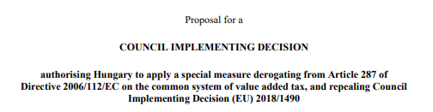
<meta>
<TLCReference xml:id="DEC_IMPL" name="docType"
href="http://publications.europa.eu/resource/authority/resource-type/DEC_IMPL"
showAs="Implementing decision"/>

</meta>

<longTitle>
<p><docStage>Proposal for a</docStage>
<docType refersTo="~DEC_IMPL">COUNCIL IMPLEMENTING DECISION</docType>
<docPurpose>authorising Hungary to apply a special measure derogating from Article 287 of <ref href="http://data.europa.eu/eli/dir/2006/112">Directive 2006/112/EC on the common system of value added tax</ref>, and repealing <ref href="http://data.europa.eu/eli/IMPL_DEC/2018/1490">Council Implementing Decision (EU) 2018/1490</ref></docPurpose></p>
</longTitle>

Notes in <coverPage>
The notes in the cover page comes from two sources:
- The <container> in the <coverPage> can have specific notes.
Note in the cover page is numbered with “*”.
- On the other hand, the <longTitle> element of the <coverPage> is a copy of the title of the legal text (=the <longTitle> of the <preface> of the <bill>).
One business constraint is that, if the title of the legal text has a note, this note must be also in the <coverPage> without being renumbered.
It means that, sometimes, the <coverPage> can have 2 notes with the same note number.
In this example, there are two notes with marker “*”:
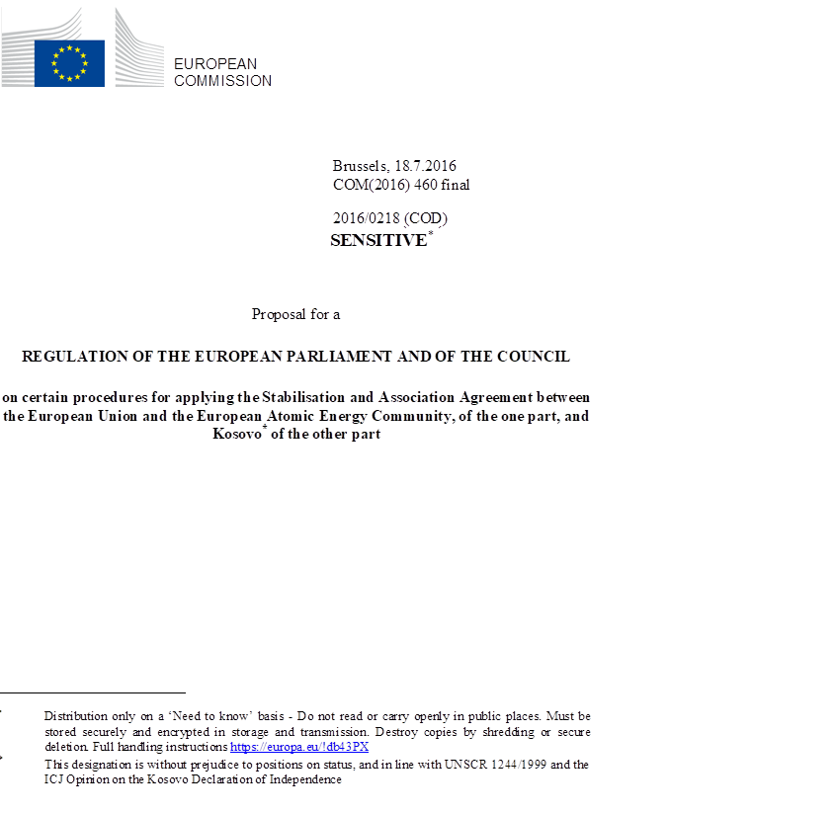
It will be marked as
<container name="…">
<p>SENSITIVE<authorialNote marker=”*” placement=”bottom”><p>Distribution only on a ‘Need to know’ basis – Do not read or carry openly in public places….</p></authorialNote>
</container>
…
<longTitle>
<p><docStage>Proposal for a</docStage>
<doctype refersTo=”~REG”>Regulation of the European Commission and of the Council</doctype>
<docPurpose>on certain procedures for applying the Stabilisation and Association Agreement between the European Union and the European Atomic Energy Community, of the one part, and Kosovo<authorialNote marker=”*” placement=”bottom”><p>This designation is without prejudice to position…</p></authorialNote> of the other part</docPurpose>

<container name="eeaRelevance">
This optional container indicates that the bill is with relevance to the European Economic Area.
Example
<container name="eeaRelevance">
<p>(Text with EEA relevance)</p>
</container>

<container name="associatedReferences">
This container contains the references to the associated documents ( e.g. SWD document, SEC document, …) associated to this Proposal.
This <container> can contain multiple <p>, one for each reference.
Each reference of a associated document MUST be marked with a <ref> element. The mandatory @href attribute contains the ELI URI or CELEX URI of the associated document.
Exemple
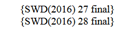
<container name="associatedReferences">
<p>{<ref href="http://data.europa.eu/eli/dl/proc/.../.../cod/doc/swd/SWD_2016_27/final">SWD(2016) 27 final">SWD(2016) 27 final </ref>} </p>
<p>{<ref href="http://data.europa.eu/eli/dl/proc/.../.../cod/doc/swd/SWD_2016_28/final"> SWD(2016) 28 final</ref>}</p>
</container>

<container name="mainDocLanguage">
This container contains the language code of the document.
The language code inside MUST be identified with an <inline name="language"> element.
The <inline> element for the language MUST have an attribute @refersTo pointing to the <FRBRlanguage> metadata.
Example

<meta>
…
<FRBRlanguage xml:id="~FRBRlanguage" language="en"/>
…
</meta>
<container name="mainDocLanguage">
<p><inline name="language" refersTo="~FRBRlanguage">EN</inline></p>
</container>

<collectionBody>
It contains one component per subdocuments.

<component> for the Explanatory Memorandum
The <documentRef> has as attributes.
- A mandatory @href attribute containing the path to the file containing the Explanatory Memorandum;
- A mandatory @showAs attribute containing the content of the <longTitle>/<p>/<docType> element of this subdocument
<component>
<documentRef href="….xml" showAs="EXPLANATORY MEMORANDUM"/>
</component>

<component> for legal text
The <documentRef> has as attributes:
- A mandatory @href attribute containing the path to the file containing the legal text;
- the content of the <longTitle>/<p>/<docType> element of the corresponding subdocument
Example
<component>
<documentRef href="….xml"
showAs="REGULATION OF THE EUROPEAN PARLIAMENT AND OF THE COUNCIL"/>
</component>

<component> for the Legislative Financial and Digital Statement and the Legislative Financial Statement
The <documentRef> has as attributes:
- A mandatory @href attribute containing the path to the file containing the Legislative Financial and Digital Statement or the Legislative financial statement;
- the content of the <longTitle>/<p>/<docType> element of the corresponding subdocument
Example
<component>
<documentRef href="….xml" showAs="LEGISLATIVE FINANCIAL STATEMENT"/>
</component>
Or
<component>
<documentRef href="….xml" showAs="LEGISLATIVE FINANCIAL AND DIGITAL STATEMENT"/>
</component>

The mark-up of the Explanatory Memorandum
The Explanatory Memorandum is a document included in the Proposal of the Commission that explains the context and the purpose of the proposal.
This subdocument is marked with a <doc> element

@name attribute
The attribute @name MUST have the value "EXPL_MEMORANDUM", corresponding to the code of the authority table "resource-type" for this type of document.

Overall organization
This document type has the following structure:
- <meta> mandatory
- <preface> mandatory
- <mainBody> mandatory

<meta>
The following metadata are needed:
- The metadata required by AKN4EU (see AKN4EU PART1 – section 9.5)
The @value of <FRBRprescriptive> is set to “false”
- a <TLCReference name="docType"> with the information on the entry EXPL_MEMORANDUM in the authority table "resource-type".

<preface>
The preface contains the title of the Explanatory Memorandum (which is the type of the document).
The title MUST be in the element <longTitle>. The <longTitle> MUST contain only one <p>.
The <p> MUST contain the <docType> element with a mandatory @refersTo attribute pointing to the <TLCReference name="docType"> for the 'EXPL_MEMORANDUM' entry.
Example:
<meta>
<TLCReference xml:id="EXPL_MEMORANDUM" name="docType"
href="http://publications.europa.eu/resource/authority/resource-type/EXPL_MEMORANDUM"
showAs="Explanatory memorandum"/>
</meta>

<preface>
<longTitle>
<p><docType refersTo="~EXPL_MEMORANDUM">EXPLANATORY MEMORANDUM</docType></p>
</longTitle>
</preface>

<mainBody>
The content of the Explanatory Memorandum is organised in well-defined and standardised hierarchical structures (referred to by the Common Vocabulary as ‘section’).
However, the Explanatory Memorandum does not use the Akoma Ntoso hierarchical elements for the mark up of its content.
- The sections MUST be marked up with the element <tblock>.
- The whole content of the section MUST be inside a <blockContainer> element.
NB: very short ‘Explanatory Memorandum’ can have no section. In this case, they are composed of <p>, <blocklist>, <table> or <block name=”crossheading”>

The “unnumbered paragraph(s)” before the “section(s)”
One or more unnumbered paragraph can occur before the sections.
They are marked as
- <p> when they are simple block and
- <blocklist when they are composed of sequence of points preceded by an introductory part,
- <table>.

The section: <tblock>
Each <tblock> is composed of
- a mandatory <num> element (the <num> element contains the number of the section or the bullet sign if the section is not numbered)
- a mandatory <heading> element containing the subject of the section
- its content:
  - <blockContainer> or
  - multiple <tblock> if the content is composed of nested sections.

The specific content of a section: <blockContainer>
Each section for which content is allowed MUST have an element <blockContainer>.
The structure of the <blockContainer> is composed of one or more of these elements:
- <p>
- <blockList>, composed of <item>, optionally preceded by a <listIntroduction> (introductory part) and optionally followed by a <listWrapUp> (conclusion of the list).
- table.
- <block name=”crossheading> (independent subjects).
Example:
<tblock>
<num>•</num>
<heading>Fundamental rights</heading>
<blockContainer>
<p>Not applicable</p>
</blockContainer>
</tblock>

Overall example of <mainBody>
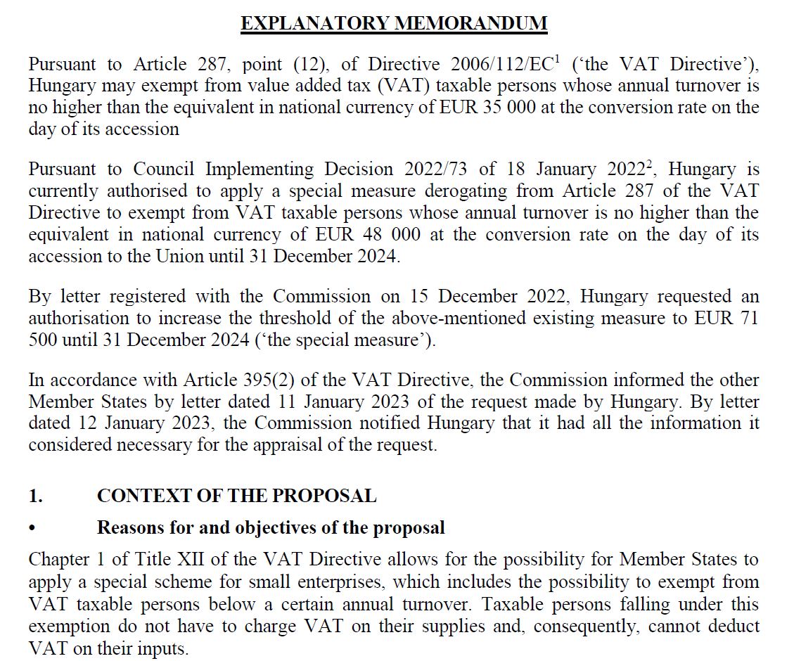
will be marked as
<mainBody>
<p> Pursuant to Article 287, point (12), of Directive 2006/112/EC<authorialNote marker="1" placement="bottom"><p>OJ L 347, 11.12.2006, p. 1.</p></authorialNote> (‘the VAT Directive’), Hungary may exempt from value added tax (VAT) taxable persons whose annual turnover is no higher than the equivalent in national currency of EUR 35 000 at the conversion rate on the day of its accession Pursuant to Council Implementing </p>
<p>Decision 2022/73 of 18 January 2022<authorialNote marker="2" placement="bottom">
<p>Council Implementing Decision(EU) 2022/73 of 18 January 2022 amending Implementing Decision (EU) 2018/1490 as regards authorisation to Hungary to apply for a further period the special measure derogating from Article 287 of Directive 2006/112/EC on the common system of value added tax (OJ L 12, 19.1.2022, p. 148–150).</p>
</authorialNote>, Hungary is currently authorised to apply a special measure derogating from Article 287 of the VAT Directive to exempt from VAT taxable persons whose annual turnover is no higher than the equivalent in national currency of EUR 48 000 at the conversion rate on the day of its accession to the Union until 31 December 2024. </p>
<p>By letter registered with the Commission on 15 December 2022, Hungary requested an authorisation to increase the threshold of the above-mentioned existing measure to EUR 71 500 until 31 December 2024 (‘the special measure’). </p>
<p>In accordance with Article 395(2) of the VAT Directive, the Commission informed the other Member States by letter dated 11 January 2023 of the request made by Hungary. By letter dated 12 January 2023, the Commission notified Hungary that it had all the information it considered necessary for the appraisal of the request. </p>
<tblock>
<num>1.</num>
<heading>CONTEXT OF THE PROPOSAL</heading>
<tblock>
<num>.</num>
<heading>Reasons for and objectives of the proposal</heading>
<blockContainer>
<p> Chapter 1 of Title XII of the VAT Directive allows for the possibility for Member States to apply a special scheme for small enterprises, which includes the possibility to exempt from VAT taxable persons below a certain annual turnover. Taxable persons falling under this exemption do not have to charge VAT on their supplies and, consequently, cannot deduct VAT on their inputs. </p>
…
</blockContainer>
</tblock>
…
</tblock>
</mainBody>

The mark-up of the Legal Text
This subdocument is marked with a <bill> element

@name attribute
The attribute @name MUST have one of these value, depending on the type of Legal text: "DEC", DIR", "REG", DEC_IMPL.

Overall organization
This document type has the following structure:
- <meta> mandatory
- <preface> mandatory
- <preamble> mandatory
- <mainBody> mandatory
- <conclusions> mandatory
- <attachments> mandatory if there is one or more annex(es)

(See the general mark-up for "AKN4EU PART 2 – 2.1 EU acts")

The mark-up of the Legislative Financial and Digital Statement and of the Legislative Financial Statement
The Legislative Financial and Digital Statement and the Legislative Financial Statement are documents included in the Proposal for an act, which explains the financial (and Digital) implication of the adoption of this Proposal.
These subdocuments are marked with a <doc> element. The 2 documents shares the same structure, so the AKN4EU mark-up follows the same rule (except for the @name attribute of <doc>).

@name attribute
The attribute @name MUST have the value
- "STAT_FINANC_LEGIS", corresponding to the code of the authority table "resource-type" for Legislative and Financial Statement;
- ‘STAT_ DIGIT_FINANC_LEGIS, corresponding to the code of the authority table "resource-type" for the Financial and Digital Statement.

Overall organization
This document type has the following structure:
- <meta> mandatory
- <preface> mandatory
- <mainBody> mandatory

<meta>
The following metadata are needed:
- The metadata required by Akoma Ntoso (<identification> section)
- The standard AKN4EU metadata, as described in Part 1 of specification;
- The @value of <FRBRprescriptive> is set to “false”
- A <TLCReference name="docType"> with the information on the entry ‘STAT_FINANC_LEGIS’ or ‘STAT_DIGIT_FINANC_LEGIS’ in the authority table "resource-type".

<preface>
The preface contains the title of the Financial Statement (which is the type of the document).
The title MUST be in the element <longTitle>. The <longTitle> MUST contain only one <p>.
The <p> MUST contain the <docType> element with a mandatory @refersTo attribute pointing to the <TLCReference name="docType"> for the Financial Statement entry.
Example:
<meta>
<TLCReference xml:id="STAT_FINANC_LEGIS" name="docType"
href="http://publications.europa.eu/resource/authority/resource-type/STAT_FINANC_LEGIS"
showAs="Legislative Financial Statement"/>
</meta>

<preface>
<longTitle>
<p><docType refersTo="STAT_FINANC_LEGIS">LEGISLATIVE FINANCIAL STATEMENT</docType></p>
</longTitle>
</preface>
Or
<meta>
<TLCReference xml:id="STAT_DIGIT_FINANC_LEGIS" name="docType"
href="http://publications.europa.eu/resource/authority/resource-type/STAT_DIGIT_FINANC_LEGIS"
showAs="Legislative Financial and Digital Statement"/>
</meta>

<preface>
<longTitle>
<p><docType refersTo="~STAT_DIGIT_FINANC_LEGIS">LEGISLATIVE FINANCIAL AND DIGITAL STATEMENT</docType></p>
</longTitle>
</preface>

<mainBody>
Currently, the Legislative Financial Statement and the Legislative Financial and Digital Statement has a well-defined structure.
The structure is the following:
- A core structure composed of “independent points”
- A low level structure, grouping all structures available inside an “independent point”.

Core structure: element <level>
In AKN4EU, the “independent point” MUST be marked with the element <level>.
Example:
<mainBody>
<level>
<num>1.</num>
<content>
<p>Obligations of manufacturers</p>
</content>
</level>
<level>
<num>1.1</num>
<content>
<p>The satisfactory operation of the multi-stage type-approval requires joint action by all the manufacturers concerned. To that end approval authorities must ensure, before granting first and subsequent stage type-approvals, that suitable arrangements exist between the relevant manufacturers for the supply and interchange of documents and information, so that the completed type of vehicle meets the technical requirements of all the relevant regulatory acts listed in Annex II. Such information must include details of relevant system, component and separate technical unit type-approvals and of vehicle parts that form part of the incomplete vehicle but have not yet been type-approved.</p>
</content>
</level>
<level>
<num>1.2</num>
<content>
<p>Each manufacturer involved in a multi-stage type-approval shall be responsible for the approval and conformity of production of all systems, components or separate technical units manufactured or added by that manufacturer to the previously built stage. The manufacturer of the subsequent stage shall not be responsible for objects that have been approved in an earlier stage, except where that manufacturer modifies relevant parts to such an extent that the previously granted type-approval becomes invalid.</p>
</content>
</level>
<level>
<num>2.</num>
<content>
<p>Obligations of approval authorities</p>
</content>
</level>

Low level structures
In Legislative Financial Statement, complex <level> can have the following sub-structures:

<heading>
For the subject of the independent point

<content>
When the level has one simple content :

<subparagraph>
When the <level> has multiple blocks, for the subparagraph that is a simple block.

Subparagraph that is an object
Inside the Financial Statement, the following objects can occur
- Table
- Mathematical formula with or without legend.
Example
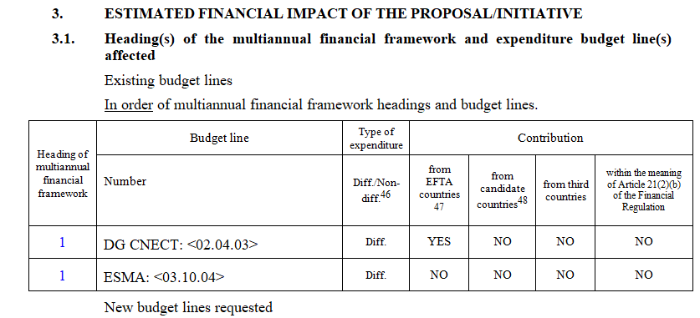
Will be marked as
<level><num>3.</num>
<heading>ESTIMATED FINANCIAL IMPACT OF THE PROPOSAL/INITIATIVE</heading>
</level>
<level><num>3.1.</num>
<heading>Heading(s) of the multiannual financial framework and expenditure budget line(s) affected</heading>
<subparagraph>
<content>
<p>Existing budget lines</p>
</content>
</subparagraph>
<subparagraph>
<content>
<p><u>In order</u> of multiannual financial framework headings and budget lines.</p>
</content>
</subparagraph>
…
<!— subparagraph that is a table object -->
</level>

<list>
When the subparagraph is composed of an introductory part following by a sequence of points or a sequence of indents.
Check structures are also present.
Example
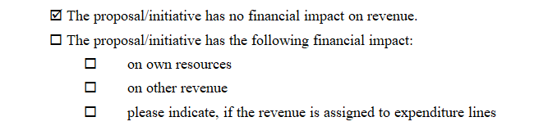
<list class=”CHECK”>
<indent>
<num><inline name=“checked”>&#x2611;</inline></num>
<content>
<p>The proposal/initiative has no financial impact on revenue.</p>
</content>
</indent>
<indent>
<num><inline name=”unchecked”>&#x2610;</inline></num>
<list class=”CHECK”>
<subparagraph refersTo=”~INP”>
<content>
<p>The proposal/initiative has the following financial impact:</p>
</content>
</subparagraph>
<indent>
<num><inline name=”unchecked”>&#x2610;</inline></num>
<content>
<p>on own resources</p>
</content>
</indent>
<indent>
<num><inline name=”unchecked”>&#x2610;</inline></num>
<content>
<p>on other revenue</p>
</content>
</indent>
<indent>
<num><inline name=”unchecked”>&#x2610;</inline></num>
<content>
<p>please indicate, if the revenue is assigned to expenditure lines</p>
</content>
</indent>
</list>
</indent>
</list>

EP Texts adopted

EP Text Adopted : use cases for AKN4EU
The AKN4EU baseline version contains the following use cases for the EP text adopted:
- EP Text Adopted that contains only a Legislative Resolution
- EP Text Adopted that contains a Legislative Resolution and a Consolidated text abridged, in the context of an agreement with the Council
All these document has a cover page.

Case 1: Legislative resolution alone
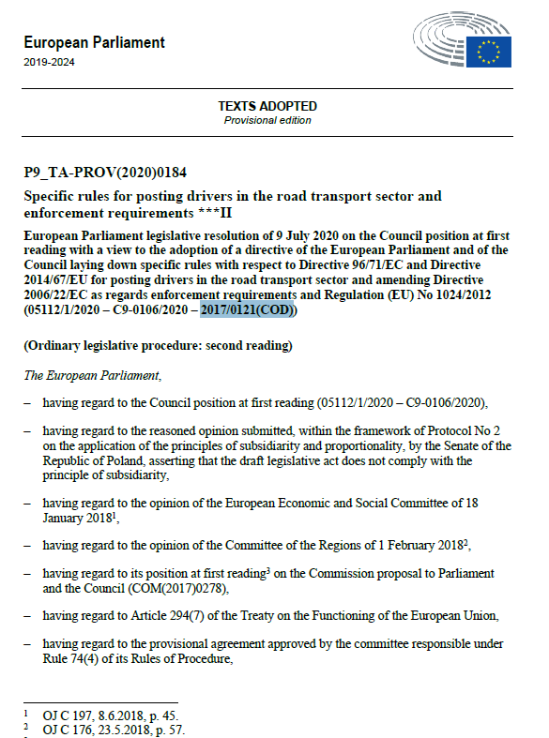
Legislative resolution
Cover page

Case 2: Legislative resolution and Consolidated text, in the context of an agreement with the Council
Cover page
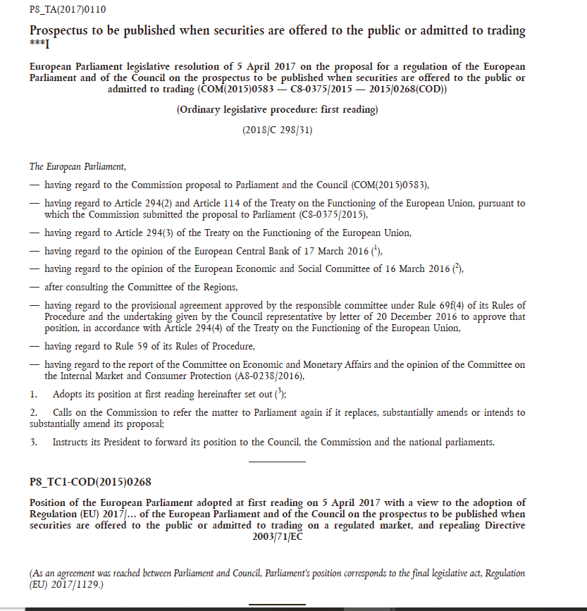
Consolidated Text abrigded
Legislative resolution

AKN4EU mark-up of the EP Texts adopted: overall structure
The EP Text Adopted documents follow the standard AKN4EU model of a document:
- The entry point (main.xml of a .leg package) is a <documentCollection>.
- The <documentCollection> contains the information of the cover page. For the Parliament documents, these information are split in the <coverPage> and the <preface> elements.
- The <documentCollection has, as subdocument:
- an mandatory Legislative Resolution
- an optional Consolidated text.
For each subdocument, the <documentCollection> contains, inside the <collectionBody>, one <component> element.
- The content of each subdocument is in a specific file
Document type of the subdocuments
- For the legislative Resolution, the file MUST have as document type:
<bill name="RES_LEGIS">
- In the use case studied, the "Consolidated act, abridged".
It is a <bill> with the type corresponding to the type of the legal text ("REG", "DIR", "DEC").
As the text of the bill is not displayed, the @status of <preamble> and <body> are set to "ignored"

The mark-up of the <documentCollection>

@name attribute
The attribute @name MUST have the value "ADOPT_TEXT ", corresponding to the code of the authority table "resource-type" for this type of document.

<meta>
The following metadata are needed:
- The metadata required by AKN4EU (see AKN4EU PART1 – section 9.5),
The @value of the <FRBRprescriptive> metadata MUST be set to "false".
- For the value of the @name attribute of the <documentCollection>, it MUST exist
a <TLCReference name="docType"> with the information on the corresponding entry in the authority table "resource-type" (the value of the attribute @name is the authority code)
Example
<documentCollection name="ADOPT_TEXT">
<meta>
...
<references source="~...">
...
<TLCReference xml:id="ADOPT_TEXT" name="docType"
href="http://publications.europa.eu/resource/authority/resource-type/ADOPT_TEXT"
showAs="Texts adopted"/>
...
</references>
</meta>
...
</documentCollection>

- In the <analysis>/<otherReferences>, an <implicitReference> SHOULD exist, that identify the document on which this EP Text Adopted reacts (if such document exists).
A <TLCReference name="docType"> MUST exist with the corresponding type of document (@xml:id corresponding to the reference in the @refersTo of the <implicitReference>).
Example
In the case of a first reading, the document referenced is the Proposal for an act:
<analysis source="...">
<otherReferences source="~PUBL">
<implicitReference xml:id="com-2015-583" refersTo="~PROP_ACT"
href="http://data.europa.eu/eli/prop_act/2015/583" showAs="COM(2015)0583"/>
</otherReferences>
</analysis>
<references source="~...">
<TLCReference xml:id="PROP_ACT" name="docType"
href="http://publications.europa.eu/resource/authority/resource-type/PROP_ACT"
showAs="Proposal for an act"/>
</references>
- In <references>, a <TLCReference name="procedureReference"> MUST exist, if the document is associated to a legislative procedure.
As forth indication of the @shortForm attribute, the step inside the legislative procedure MUST be indicated; this information is expressed using a code from the authority table "procedure-phase".
Example (a procedure in second reading)
<TLCReference xml:id="procedure_2011_458" name="procedureReference"
href="http://eur-lex.europa.eu/procedure/EN/2011_458" showAs="2011/0458 (COD)" shortForm="2011/458/COD/RDG2"/>

- A corresponding <TLCProcess> CAN exist to make a explicit link between this information and the corresponding entry in the authority table:
<TLCProcess xml:id="RDG2" href="http://publications.europa.eu/resource/authority/procedure-phase/RDG2" showAs="Second reading"/>
Example
Will be marked as following
<documentCollection name="ADOPT_TEXT">
<meta>
...
<analysis source="~...">
<otherReferences source="~...">
<implicitReference refersTo="~POSIT"
href="http://data.europa.eu/eli/posit/2020/5112_1" showAs="05112/1/2020"/>
<!-- optional -->
</otherReferences>
</analysis>
...
<references source="~...">
<TLCReference xml:id="ADOPT_TEXT" name="docType"
href="http://publications.europa.eu/resource/authority/resource-type/ADOPT_TEXT"
showAs="Texts adopted"/>
<TLCReference xml:id="POSIT" name="docType"
href="http://publications.europa.eu/resource/authority/resource-type/POSIT"
showAs="Position"/> <!-- optional only if <implicitReference> -->
<TLCReference xml:id="procedure_2017_121" name="procedureReference"
href="http://eur-lex.europa.eu/procedure/EN/2017_121"
showAs="2017/0121(COD)" shortForm="2017/121/COD/RDG2"/>
<TLCProcess xml:id="RDG2" href="http://publications.europa.eu/resource/authority/procedure-phase/RDG2"
showAs="Second reading"/> <!-- optional -->
</references>
</meta>
...
<container name="relatedProc">
<p><shortTitle>Specific rules for posting drivers in the
road transport sector and enforcement requirements</shortTitle>
<inline name="procSymbol" refersTo="~procedure_2017_121">***II</inline></p>
</container>

<coverPage> and <preface>
The content of the cover page is split into the elements <coverPage> and <preface>.
In the following schema, the content in green is in the <preface>, the other content is in the <coverPage>.

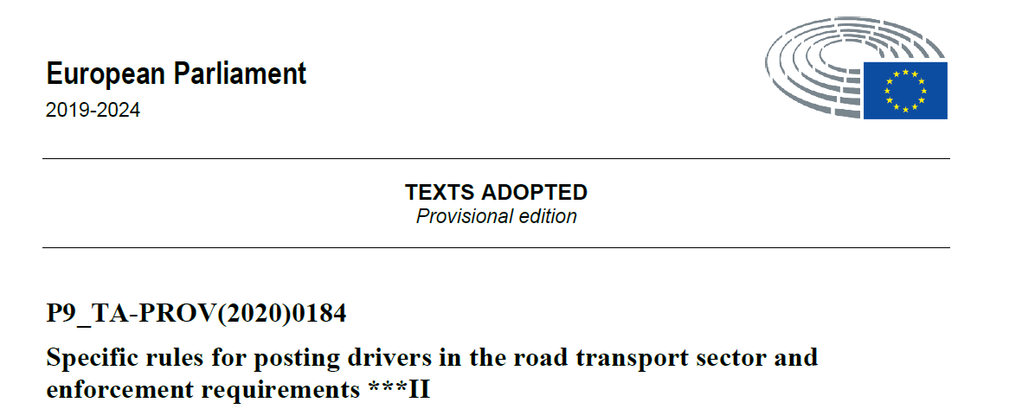
<container name="logo">

<container name="mainDoc">

<container name="relatedProc">

<container name="docHeader">

<container name="typeOfDocument">

<container name="actingEntity">

<preface>

<coverPage>
The <coverPage> contains the following <container>:

<container name="actingEntity">
It contains two <p> elements:
- One with the <organization> with the mandatory @refersTo attribute pointing to an <TLCOrganization> element in the <references> part of the metadata.
- One with the "EP legislature". This information MUST be marked with the AKN element <legislature>.
Example


<meta>
<TLCOrganization xml:id="EP"
href="http://publications.europa.eu/resource/authority/corporate-body/EP"
showAs="European Parliament"/>
</meta>
…
<container name="actingEntity">
<p><organization refersTo="~EP">European Parliament</organization></p>
<p><legislature>2019-2024</legislature></p>
</container>

<container name="logo">
No specific mark-up
Example
<container name="logo">
<p><img src="EP.png"/></p>
</container>

<container name="docHeader">
This container contains the information on the "title of the document".
In this class of EP document, the <docHeader> contains only the type of the document (inside a <container name="typeOfDocument">)
<container name="typeOfDocument"> can contain two <p> elements:
- One, always present, with the <docType> with the mandatory @refersTo attribute.
The @refersTo attribute MUST point to a <TLCReference name="docType">, in the <references> part of the metadata.
- One, optional, with the information on the version. The information is marked by an <inline> element with @name ="version".
Example
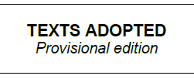
<meta>
<TLCReference xml:id="ADOPT_TEXT" name="docType"
href="http://publications.europa.eu/resource/authority/resource-type/ADOPT_TEXT"
showAs="Texts adopted"/>
</meta>
…
<container name="docHeader">
<container name="typeOfDocument">
<p><docType refersTo="~ADOPT_TEXT">TEXTS ADOPTED</docType></p>
<p><inline name="version">Provisional edition</inline></p>
</container>
</container>

<preface>
The <preface> contains the following <container>:

<container name="mainDoc">
This <container> contains the reference of the document in a <block name="reference">.
The reference MUST be in a <docNumber> element
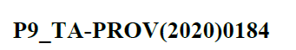

<container name="mainDoc">
<block name="reference"><docNumber>P9_TA-PROV(2020)0184</docNumber></block>
</container>

<container name="relatedProc">
This <container> contains information related to the Legislative Procedure : a 'short title' with the "subject", and a symbol representing the current step in the legislative procedure.
The symbol is marked with a <inline> element with the mandatory @name attribute sets to "procSymbol"
It MUST contain a @refersTo attribute pointing to a <TLCReference name= "procedureReference ">.
This <TLCReference> contains the URI of the EUR-lex page of the procedure.
Example
<meta>
<TLCReference xml:id="procedure_2011_458" name="procedureReference"
href="http://eur-lex.europa.eu/procedure/EN/2011_458" showAs="2011/0458 (COD)" shortForm="2011/458/COD/RDG2"/>
</meta>
…
<container name="relatedProc">
<p><shortTitle>Specific rules for posting drivers in the
road transport sector and enforcement requirements</shortTitle>
<inline name="procSymbol" refersTo="~procedure_2011_458">***II</process></p>
</container>

<collectionBody>
It contains one component per subdocuments.

<component> for the Legislative Resolution
The <documentRef> has as attributes.
- A mandatory @href attribute containing the path to the file containing the Legislative Resolution
- A mandatory @showAs attribute containing the content of the <longTitle>/<p>/<docType> element.
<component>
<documentRef href="legislative_resolution_123.xml"
showAs="European Parliament legislative resolution"/>
</component>

<component> for the Consolidated text abridged
When the EP adopted texts contains a Consolidated text, there is an additional <component> element.
The <documentRef> has, as value for the @showAs attribute:
- the content of the <docType> in the <longTitle>/<p>/<docStage> of the corresponding subdocument
or, if this element does not exist,
- the <docType> in the <longTitle>/<p> itself.
Example
<component>
<documentRef href="….xml"
showAs="Position of the European Parliament"/>
</component>

The mark-up of the Legislative resolution
This subdocument is marked with a <bill> element

@name attribute
The attribute @name MUST have the value "RES_LEGIS", corresponding to the code of the authority table "resource-type" for this type of document.

Overall organization
This document type has the following structure:
- <meta> mandatory
- <preface> mandatory
- <preamble> mandatory
- <body> mandatory

<meta>
- The metadata required by AKN4EU (see AKN4EU PART1 – section 9.5),
The @value of the <FRBRprescriptive> metadata MUST be set to "true".

- A <TLCReference name="docType"> MUST exist for the authority code RES_LEGIS:
<TLCReference xml:id="RES_LEGIS" name="docType"
href="http://publications.europa.eu/resource/authority/resource-type/RES_LEGIS"
showAs="Legislative resolution"/>
- In the <analysis>/<otherReferences>, an <implicitReference> SHOULD be inserted with the information on the document at the basis of this Legislative Resolution.
A <TLCReference name="docType"> MUST exist with the @xml:id corresponding to the @xml:id referenced in the @refersTo attribute of the <implicitReference>.
For example, in the case of a second reading, the reference to the Position of the Council:
<implicitReference xml:id="pos-2020-5112_1" refersTo="~POSIT"
<!-- ELI uri = draft !!! -->
href="http://data.europa.eu/eli/posit/2020/5112_1" showAs="05112/1/2020"/>
…
<references source="…">
<TLCReference xml:id="POSIT" name="docType"
href="http://publications.europa.eu/resource/authority/resource-type/POSIT"
showAs="Position"/> <!-- optional only if <implicitReference> -->
</source>
- In the <references>, A <TLCReference name="procedureReference"> MUST exist.
Remainder: The forth information in the @shortForm is the step inside the legislative procedure;
this information is expressed using a code of the authority table "procedure-phase".
<TLCReference xml:id="procedure_2011_458" name="procedureReference"
href="http://eur-lex.europa.eu/procedure/EN/2011_458" showAs="2011/0458 (COD)" shortForm="2011/458/COD/RDG2"/>

- A corresponding <TLCProcess> CAN exist to make a explicit link to the entry in the authority table:
<TLCProcess xml:id="RDG2" href="http://publications.europa.eu/resource/authority/procedure-phase/RDG2" showAs="Second reading"/>

<preface>
It has the following sub-elements
- <longTitle>
Specificity: the <longTitle> contains the title and some information related to the legislative procedure in the same block. Therefore, inside the <p> element,
  - <docTitle> MUST exist, that contains the part related to the title of the document
  - <inline name="relatedProc"> MUST exist that contains the information related to the legislative procedure.

Inside the <inline name="relatedProc">,
- The first document number of the parenthesis is the document on which is provided the Consolidated text. It MUST be marked as following:
  - A <docNumber> element, with a mandatory @refersTo attribute pointing to a <TLCReference name="identifier">.
  - Inside this <docNumber>, a <ref> element SHOULD be inserted with the following alternative value for the mandatory @href attribute :
    - reference to the corresponding metadata that is the corresponding <implicitReference> that contains the ELI URI of the document.
    - directly the ELI URI of the document.
- The second document number of the parenthesis is the "session number" of the same document. It MUST be marked as following:
  - A <docNumber> element, with a mandatory @refersTo attribute pointing to a <TLCReference name="identifier">.
- The third information is the procedure number. It MUST be marked with a <docketNumber> with a @refersTo attribute pointing to the corresponding <TLCReference> with the @name="procedureReference".
Example

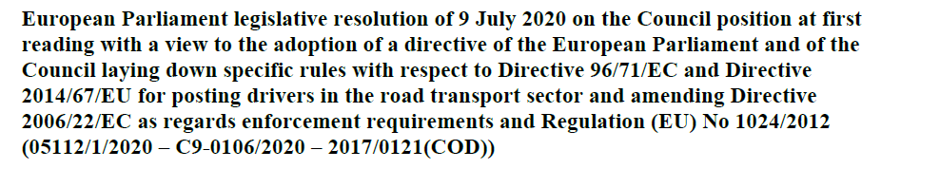

<meta>
<analysis source="~EP">
<otherReferences source="~EP">
<implicitReference xml:id="pos2020-5112-1" refersTo="~POSIT"
href="http://data.europa.eu/eli/posit/2020/5112/1" showAs="05112/1/2020"/>
<!-- ELI uri = draft !!! -->
</otherReferences>
</analysis>
<references>
<TLCReference xml:id="RES_LEGIS" name="docType"
href="http://publications.europa.eu/resource/authority/resource-type/RES_LEGIS" showAs="Legislative resolution"/>
<TLCReference xml:id="id-C9-0106-2020" name="identifier"
href="http://publications.europa.eu/resource/authority/document-identifier-format/SESSION_NUMBER" showAs="C9-0106/2020" shortForm="C/9/106/2020"/>

<TLCReference xml:id="id-5112-1-2020" name="identifier"
href=" http://publications.europa.eu/resource/authority/document-identifier-format/CSL_NUMBER" showAs="05112/1/2020" shortForm="5112/1/2020"/>
<TLCReference xml:id="procedure_2017_121" name="procedureReference"
href="http://eur-lex.europa.eu/procedure/EN/2017_121" showAs="2017/0121(COD)" shortForm="2017/121/COD/RDG2"/>
</meta>
…
<longTitle>
<p><docTitle><docType refersTo="~RES_LEGIS">European Parliament legislative resolution</docType> of <date date="2020-07-09">9 July 2020</date>
<docPurpose>on the Council position at first reading with a view to the adoption of a directive of the European Parliament and of the Council laying down specific rules with respect to <ref href="http://data.europa.eu/eli/dir/1996/71">Directive 96/71/EC</ref> and <ref href="http://data.europa.eu/eli/dir/2014/67">Directive 2014/67/EU</ref> for posting drivers in the road transport sector and amending <ref href="http://data.europa.eu/eli/dir/2006/22">Directive 2006/22/EC</ref> as regards enforcement requirements and <ref href="http://data.europa.eu/eli/reg/2012/1024">Regulation (EU) No 1024/2012</ref> </docPurpose></docTitle>
<inline name="relatedProc">(<docNumber refersTo="~id-5112-1-2020"><ref href="="~pos2020-5112-1">05112/1/2020</ref></docNumber> – <docNumber refersTo="~id-C9-0106-2020">C9-0106/2020</docNumber> – <docketNumber refersTo="~procedure_2017_121">2017/0121(COD)</docketNumber>)</inline></p>
</longTitle>

- <container name="relatedProc">
It contains inside a <p>, in a <process> element, the information related to the step of the legislative procedure. The process> element MUST have an @refersTo attribute pointing to the <TLCReference name="procedureReference">
Example
<container name="relatedProc">
<p><process refersTo="~procedure_2011_458">(Ordinary legislative procedure: second reading)</process></p>
</container>

<preamble>
The <preamble> contains the following sub-elements
- One mandatory <formula name="actingEntity">
as first element
- <citations> containing one or more <citation>
Remarks on the preamble of Legislative Resolution
- Each citation starts with an indent character (mdash character). This mdash is not part of the text.
To indicate that the citation is to render with mdash, the parent <citations> element MUST have a @refersTo attribute pointing to a <TLCConcept> element indicating that the <citation> is to render with a indent character (authority code "CITATION_DASH").
- Some <citation> are related to legal basis.
In this case, they SHOULD be marked with a @refersTo attribute pointing to the <TLCReference name="contentSubject"> and the @href pointing to the 'LegalBasis' concept in Eurovoc.
Example

<meta>
…
<TLCReference name="contentSubject" href="http://eurovoc.europa.eu/5456"
showAs="Legal basis" xml:id="legalBasis"/>
<TLCConcept xml:id="CITATION_DASH"
href="http://publications.europa.eu/resource/authority/subdivision-content/CITATION_DASH"
showAs="citation with dash"/>
…
</meta>
…
<citations refersTo="~CITATION_DASH">
…
<citation refersTo="~legalBasis">
<p>having regard to Article 294(7) of the Treaty on the Functioning of the European
Union,</p>
</citation>
…
</citations>

<body>
The <body> has the following sub-elements:
- Basic structures
Numbered paragraph (<paragraph> with <num>)
Example
<body>
<paragraph>
<num>1.</num>
<content>
<p>Adopts its position at first reading hereinafter set out <authorialNote marker="3"
placement="bottom"><p>This position replaces the amendments adopted on 15 September 2016 (Texts adopted <docNumber>P8_TA(2016)0353</docNumber>).</p></authorialNote>; </p>
</content>
</paragraph>
<paragraph>
<num>2.</num>
<content>
<p>Calls on the Commission to refer the matter to Parliament again if it replaces, substantially amends or intends to substantially amend its proposal;</p>
</content>
</paragraph>
<paragraph>
<num>3.</num>
<content>
<p>Instructs its President to forward its position to the Council, the Commission and the national parliaments.</p>
</content>
</paragraph>
</body>

The mark-up of the Consolidated text abridged
The AKN4EU 4.1 covers only the case of Consolidated text abridged.
The consolidated text is in fact, the draft of an EU legal text (Regulation, Directive or Decision).
It is marked as a <bill> document type.

@name attribute
The attribute @name MUST have one of these value "REG", "DIR", "DEC" (regulation, directive, decision).

Overall organization
This document type has the following structure:
- <meta> mandatory
- <preface> mandatory
- <preamble> mandatory
- <body> mandatory
- <attachments> mandatory if the <bill> has annex(es)

<meta>
- The metadata required by AKN4EU (see AKN4EU PART1 – section 9.5),
The @value of the <FRBRprescriptive> metadata MUST be set to "true".
- In the <analysis>/<otherReferences>
In the case of a Consolidated text, abridged, an <alternativeReference> SHOULD be defined containing the EU act that is the Consolidated text.
<meta>
<analysis>
<otherReferences>
<alternativeReference xml:id="reg-2017-1129" href="http://data.europa.eu/eli/reg/2017/1129"/>
</otherReferences>
</analysis>
<meta>

…corresponds to the final legislative act, <ref href="~reg-2017-1129"> Regulation (EU) 2017/1129</ref>…

<preface>
It has the following sub-elements:

<container name="mainDoc">
It contains the document identifier.
It MUST contain a <block name="reference">.
Inside, the document identifier MUST be inside a <docNumber> element
Example
<container name="mainDoc">
<block name="reference">
<docNumber>P8_TC1-COD(2015)0268</docNumber>
</block>
</container>

<longTitle>
It contains the title of the document
Given the following example,
Two informations on the type of the document:
- it provides the role of the document in the legislative procedure), and
- it is a Regulation.
To represent this, the structure inside the <longTitle>/<p> is the following:
- A <docStage>containing a <docType> and a <date>
- A <docType> (that can contain a <placeholder>)
- A <docPurpose>
The first docType has no @refersTo attribute. The second <docType> MUST have a @refersTo attribute pointing to the corresponding <TLCReference name="docType">
Example
<meta>
<TLCReference xml:id="REG" name="docType"
href="http://publications.europa.eu/resource/authority/resource-type/REG"
showAs="Regulation"/>
</meta>
<longTitle>
<p><docStage><docType>Position of the European Parliament</docType> adopted at first reading on <date>5 April 2017</date> with a view to the adoption of </docStage> <docType refersTo="~REG">Regulation <placeholder>(EU) 2017/...</placeholder> of the European Parliament and of the Council</docType> <docPurpose>on the prospectus to be published when securities are offered to the public or admitted to trading on a regulated market, and repealing <ref href="http://data.europa.eu/eli/dir/2003/71">Directive 2003/71/EC</ref></docPurpose></p>
</longTitle>

<container name="abridgedTextComment">
A special comment replace the content of the <bill>.
In this comment, the reference to the act that that is the Position of the Parliament.
In the mark-up, the comment is put in the preface, in a <container name="abridgedTextComment">
The reference, inside this comment, SHOULD refers to the <alternativeReference> inside the metadata>
Example
<meta>
<alternativeReference xml:id="reg-2017-1129"
ref="http://data.europa.eu/eli/reg/2017/1129"/>
</meta>
…
<container name="abridgedTextComment">
<p>(As an agreement was reached between Parliament and Council, Parliament's position corresponds to the final legislative act, <ref href="~reg-2017-1129"> Regulation (EU) 2017/1129</ref>.)</p>
</container>

<preamble>
When it is an abridged consolidated text, the element <preamble> has the attribute @status set to "ignored".
As the <preamble> element cannot be empty, it contains an empty <p>
Example
<preamble status="ignored">
<p/>
</preamble>

<body>
When it is an abridged consolidated text, the element <body> has the attribute @status set to "ignored".
As the <body> element cannot be empty, it contains an empty <article>
Example
<body status="ignored">
<article/>
</body>

Council documents

Council documents: use cases
All the Council documents studied have the same structure:
- A cover page
- 0, one or more "Council Explanatory" document. The Council Explanatory is without title of the document.
- Other optional subdocuments, generally identified inside the document as "ANNEX".
These optional subdocuments are not really annexes: they are in fact, the main part of the document.
In this analysis, they are named CNSDocANNEX for "Council doc annex".
A (CNSDocANN) can be:
  - An act or bill (Regulation, directive, decision, Council acts, ...)
  - A consolidated version of a <bill> or fragments of consolidated version of bill.
This is not part of AKN4EU 4.1
  - A specific document (Council conclusions, simple doc, ...)
  - Any other document without specific type
We examine the following cases and how they are split in subcomponents:
- Council internal documents in general like Note, “I/A” Item Note, “I” Item Note...
- The Statement of the Council's reasons
- The Position of the Council
- Council internal document with Draft Council act (decision for example)

Council internal documents in general
This covers among others the following Council internal documents Note, “I/A” Item Note, “I” Item Note, Working document... and provides a generic way to mark these documents.
The presentation of these documents is as follows:
- An optional cover page
- 0, one or more "Council explanatory", (a text explaining the context and content of the document)
- 0, one or more CNSDocANN.
When there is a subdocument before, the CNSDocANN is optionally preceded by some words like "ANNEX", with a numbering if there is more than one CNSDocANN.
Example
The following picture shows a Council's note with a cover page, a Council Explanatory and a CNSdocANN that contains fragments of a consolidated version of a bill.
The Council Explanatory has no "title of the document"
The word "ANNEX" at the begin of the CNSdocANN is not part of the content of CNSdocANN. It is just placed to mark the limit between Council explanatory and the CNSDocANN.
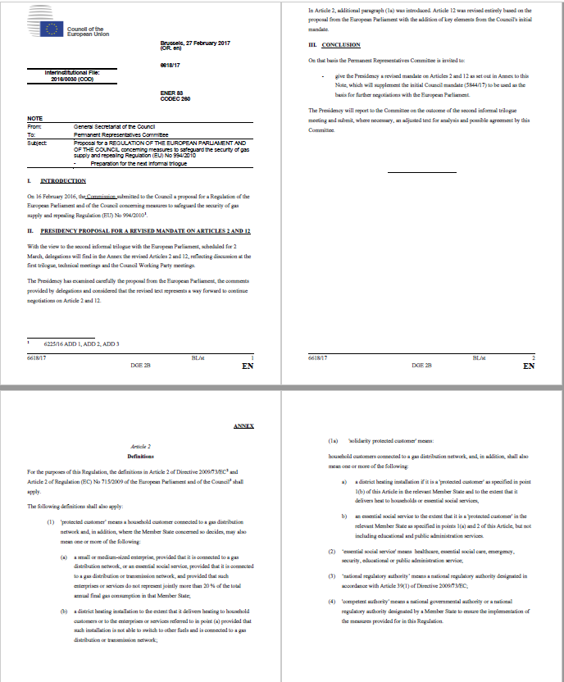
Cover page
CNSDocANN
Council Explanatory

Statement of the Council's Reasons
The Statement of the Council's Reasons is only composed of a Council Explanatory
Example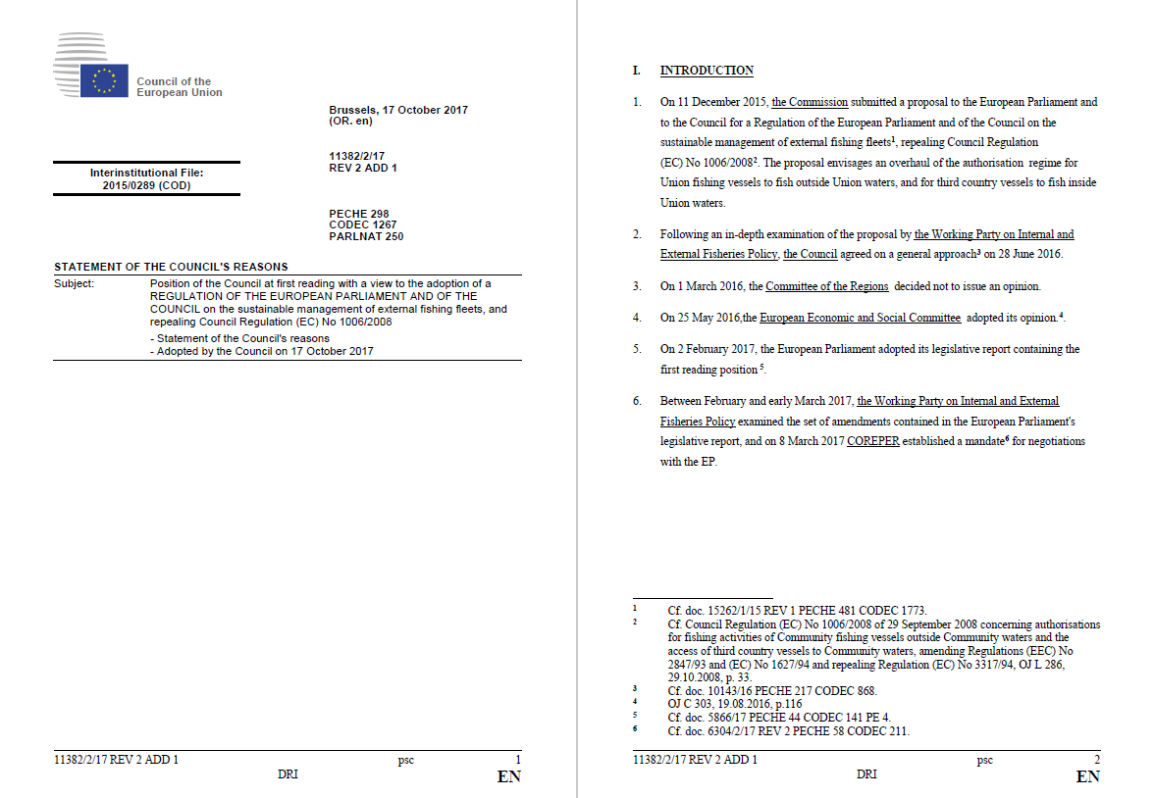
Cover page
Council Explanatory

Position of the Council
The Position of the Council is only composed of a CNSDocANN. There is no Council Explanatory and there is no word "ANNEX" at the start of the CNSDocANN
Example
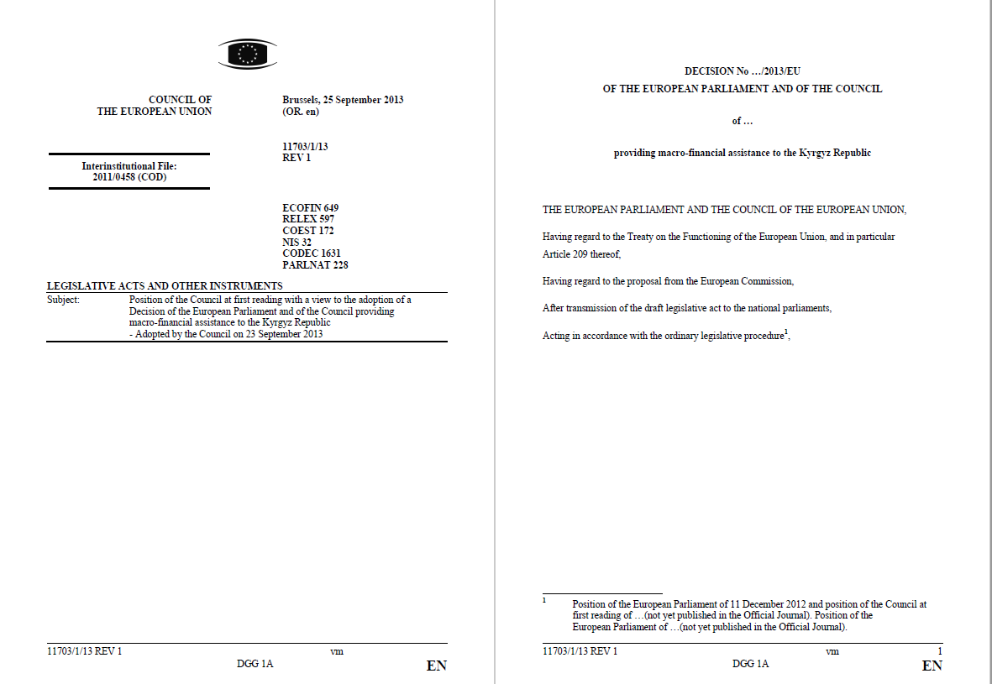
Cover page
CNSDocANN

Council internal document with (draft) act
This internal document is only composed of a CNSDocANN. There is no Council Explanatory and there is no word "ANNEX" at the start of the CNSDocANN
Example
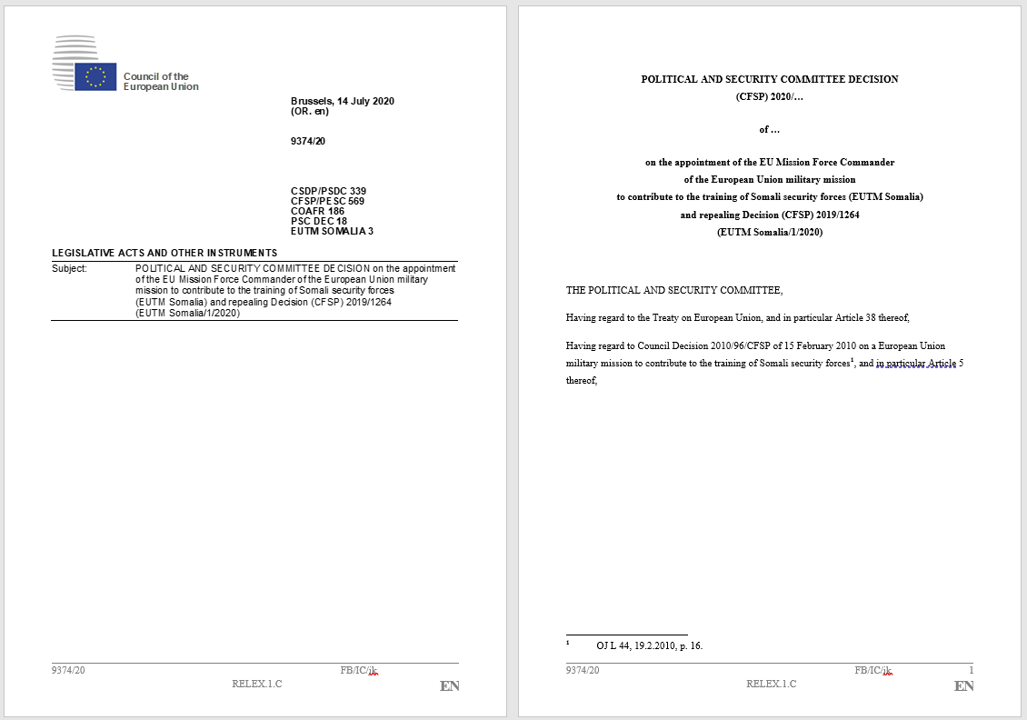
Cover page
CNSDocANN

AKN4EU mark-up of the Council documents: overall structure
Council documents follow the standard AKN4EU model of a document:
- The entry point (main.xml of the .leg package) is the <documentCollection>
- The <documentCollection> contains the <coverPage> that can be empty.
- The <documentCollection> has one or more subdocuments.
For each subdocument, the <documentCollection> contains, inside the <collectionBody>, one <component> element.
- The content of each subdocument is in a specific file:
Document type of the subdocument
- For the optional "Council Explanatory", the file MUST have as document type :
<doc name="EXPLANATORY_COUNCIL">.
- For each optional CNSDocANN, the file can have, as document type,
<doc name="..."> or <bill name="...">, depending on the content.
The value of the mandatory @name attribute is also depending on the content of the subdocument.
- The optional word "ANNEX[nn]" at the beginning of the CNSDocANN MUST be marked inside the corresponding <component> of the <documentCollection>, in a <num> element.
CNSDocANNEX

The mark-up of the <documentCollection>

The @name attribute
The <documentCollection> element has a mandatory attribute @name with one of the following values (non exhaustive list):
Component | Value of attribute @name  (from the authority table “resource-type”)
"Council Internal Document"  Generic type for Council internal document. | INTERNAL_DOC_CONSIL
NOTE | NOTE
'I' ITEM NOTE | ITEM_I_NOTE
'I/A' ITEM NOTE | ITEM_IA_NOTE
OUTCOME OF PROCEEDINGS | OUTCOME_PROCEEDINGS
WORKING DOCUMENT | WORK_DOC
STATEMENT OF THE COUNCIL'S REASONS | STAT_REASON
LEGISLATIVE ACTS AND OTHER INSTRUMENTS | ACTS_LEGIS_INSTRUMENTS
Position of the Council | POSIT
… | …

<meta>
The following metadata are needed:
- The metadata required by AKN4EU (see AKN4EU PART1 – section 9.5),
The @value of the <FRBRprescriptive> metadata MUST be set to "false".
- For the value of the @name attribute of the <documentCollection>, it MUST exist
a <TLCReference name="docType"> with the information on the corresponding entry in the authority table "resource-type" (the authority code has the same value as the value of the attribute @name)
- For each legislative procedure mentioned in the <coverPage>, it MUST exist
  - In the <references> part of metadata,
a <TLCReference name=”procedureReference”> ;
  - in the <otherReference> of the <analysis> part of metadata,
an <implicitReference>, referencing the corresponding "PROP_ACT" (Proposal for an act).
- For each <implicitReference>, a <TLCReference name=”identifier”> CAN exist.
Example
When, in the cover page of a Council internal document, there is the following information (CoV DLV20 1.9, legislative/legal procedure identifier):
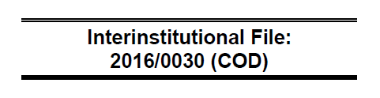
the mark-up of the content and the metadata will have the following:
<documentCollection name="INTERNAL_DOC_CONSIL">
<meta>
...
<analysis source="~...">
<otherReferences source="~PUBL">
<implicitReference for="~COM_2016_0052" refersTo="~PROP_ACT"
href="http://data.europa.eu/eli/prop_act/2016/52" showAs="COM(2016)0052"/>
</otherReferences>
</analysis>
<references source="~...">
<TLCReference xml:id="INTERNAL_DOC_CONSIL" name="docType"
href="http://publications.europa.eu/resource/authority/resource-type/INTERNAL_DOC_CONSIL" showAs="Council internal document"/>
<TLCReference xml:id="procedure_2016_30" name="procedureReference"
href="http://eur-lex.europa.eu/procedure/EN/2016_30" showAs="2016/0030 (COD)"
shortForm="2016/30/COD/RDG1"/>
<TLCReference xml:id="COM_2016_0052" name="identifier"
href="http://publications.europa.eu/resource/authority/document-identifier-format/COM_NUMBER"
showAs="COM(2016)0052" shortForm="COM/2016/52"/>
<TLCReference xml:id="PROP_ACT" name="docType"
href="http://publications.europa.eu/resource/authority/resource-type/PROP_ACT"
showAs="Proposal for an act"/>
...
</references>
</meta>
<coverPage>
...
<container name="procedureIdentifier">
<p>Interinstitutional File: <docketNumber refersTo="~procedure_2016_30"> 2016/0030 (COD) </docketNumber></p>
</container>
...
</coverPage>
...
</documentCollection>

<coverPage>
The cover page of the Council document contains information on the document. In AKN4EU these information are grouped in multiple <container>.
This section describes the <container> used. All are optional.
container name="logo"  container name="actingEntity"  container name=  "procedureIdentifier"  container name=  "docHeader"  container name=  "titleOfDocument"  container name=  "otherReferences"  container name=  "stakeholders"  container name=  "typeOfDocument" | 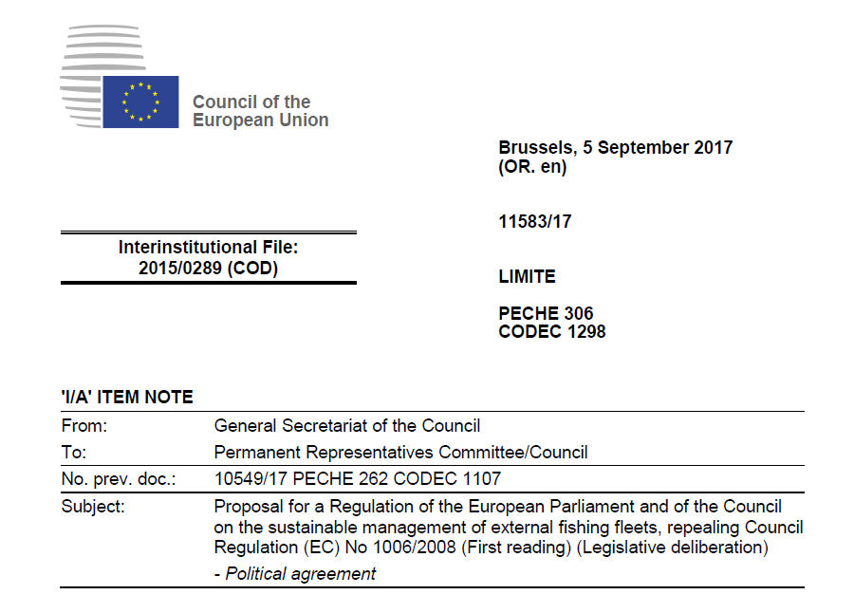  container name="mainDocReference"  block name="reference"  container name="mainDoc"  block name="placeAndDate"  block name=”mainDocOriginalLanguage”  container name="distribution"  container name="subjectMatter"

<container name="logo">
As already defined

<container name="actingEntity">
As already defined

<container name="mainDoc">
This container contains the place and date of the document and can have information on the original language(s) version of the document.
- The place and date is marked with a <block name=”placeAndDate”> element. Inside,
  - the place MUST be in a <location> element with the @refersTo attribute pointing to the corresponding entry in the <references> part of the metadata.
  - The date MUST be in a <date> element with a mandatory @date attribute.
- The information on the original language version(s) is marked with a <block name=”mainDocOriginalLanguage”>.
The language code(s) inside MUST be in a <inline name="language">
The mandatory @refersTo attribute of this <inline> points to the <FRBRlanguage> metadata if this linguistic version is the original, otherwise to the <FRBRtranslation>.
Example
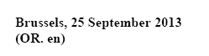
Will be marked as :
<meta>
…
<FRBRlanguage xml:id="FRBRlanguage" language="en"/>
…
<references source="~…">
<TLCLocation xml:id="BEL_BRU" href="http://publications.europa.eu/resource/authority/place/BEL_BRU"
showAs="Brussels"/>
</references>
</meta>
…
<container name="mainDoc">
<block name="placeAndDate"><location refersTo="~BEL_BRU">Brussels</location>, <date date="2013-09-25">25 September 2013</date></block>
<block name="mainDocOriginalLanguage">(OR. <inline name="language" refersTo="~FRBRlanguage">en</inline>)</block>
</container>

< container name="procedureIdentifier">
The container contains one <p> element with the following information:
- The label is in an <inline name=”label”> element
- Each procedure identifier is in a <docketNumber> element. The <docketNumber> MUST have an attribute @refersTo that points to a <TLCReference name=”procedureReference”> of the corresponding procedure. See The metadata for more information on the metadata needed for legislative/legal procedure of the document.
Example
<meta>
<TLCReference xml:id="procedure_2015_289" name="procedureReference"
href="http://eur-lex.europa.eu/procedure/EN/2015_289"
showAs="2015/0289 (COD)" shortForm="2015/289/COD"/>
</meta>
<container name="procedureIdentifier">
<p><inline name="label">Interinstitutional File:</inline>
<docketNumber refersTo="~procedure_2015_289">2015/0289 (COD)</docketNumber></p>
</container>

<container name="mainDocReference">
The number of the document is in a specific container. It is inside a <block name=”reference”> in the inline element <docNumber>.
Example
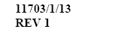
Will be marked as
<container name="mainDocReference">
<block name="reference"><docNumber>11703/1/13 REV 1</docNumber></block>
</container>

<container name=”subjectMatter”>
This part of the cover page contains a list of acronymes, with a number.
The container has as value “subjectMatter” for the attribute @name.
To be aligned to the IMMC markup, the keyword is isolated in an inline element (<inline name=”subjectCode”>).
Example
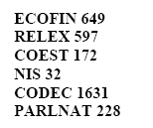
<container name="subjectMatter">
<p><inline name="subjectCode">ECOFIN</inline> 649</p>
<p><inline name="subjectCode">RELEX</inline> 597</p>
<p><inline name="subjectCode">COEST</inline> 172</p>
<p><inline name="subjectCode">NIS</inline> 32</p>
<p><inline name="subjectCode">CODEC</inline> 1631</p>
<p><inline name="subjectCode">PARLNAT</inline> 228</p>
</container>

<container name="distribution">
This <container> is optional and will only be present when there is information on the restricted distribution to the document.
Example

will be marked as:
<container name="distribution">
<p>LIMITE</p>
</container>

<container name="docHeader">
The central part of the cover page contains information like the type of the document, the issuer and addressee, the reference to other documents, the subject etc.
The <container name="docHeader"> is composed of several elements <container> to divide the information in different lines.
Example (CoV DLV20 1.10):
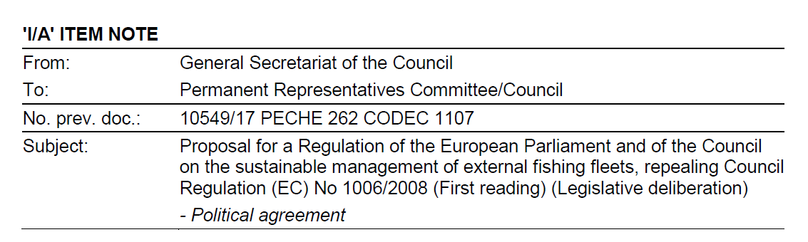

<container name="typeOfDocument">
This <container> contains one <p> that SHOULD contain a <docType> element.
<docType> has a mandatory @refersTo attribute that MUST point to the corresponding <TLCReference name="docType">
Example
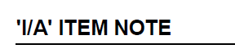
<meta>
<TLCReference xml:id="ITEM_IA_NOTE" name="docType"
href="http://publications.europa.eu/resource/authority/resource-type/ITEM_IA_NOTE" showAs="‘I/A’ item note"/>
</meta>
<container name="typeOfDocument">
<p><docType refersTo="~ITEM_IA_NOTE">'I/A' ITEM NOTE</docType></p>
</container>
If the document type is not defined in the authority table, the container contains a <p> element without <docType> element inside
Example
<container name="typeOfDocument">
<p>some ITEM NOTE</p>
</container>

<container name="stakeholders">
This optional <container> contains the information on the issuer, the addressee. It can also, when appropriate, contain the date of the event
It is composed of following elements <block>
- <block name=”issuer”>
To indicate the entity, from which the document originates
- <block name=”addressee”>
to indicate the addressee of the document.
- <block name="eventDate">
to indicate the date of the event.
Both blocks have the same structure: they MUST have an <inline name=”label”> and can have one or more elements <organisation>.
The <organisation> MUST have a @refersTo attribute that CAN point to the corresponding <TLCReference> or remains empty.
Example
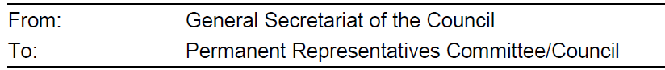
<meta>
<TLCOrganization xml:id="CONSIL_SG" href="http://publications.europa.eu/resource/authority/corporate-body/CONSIL_SG"
showAs="General Secretariat of the Council"/>
<TLCOrganization xml:id="COREPER" href="http://publications.europa.eu/resource/authority/corporate-body/COREPER"
showAs="Committee of Permanent Representatives"/>
</meta>
<container name="stakeholders">
<block name="originator"><inline name="label">From:</inline>
<organization refersTo="~CONSIL_SG">General Secretariat of the Council</organization></block>
<block name="addressee"><inline name="label">To:</inline>
<organization refersTo="~COREPER">Permanent Representatives Committee/Council </organization></block>
</container>

The @refersTo of the organization can be empty
Example
<block name="addressee"><inline name="label">To:</inline>
<organization refersTo="">Delegations </organization></block>

<container name="otherReferences">
This optional <container> can contain the following 2 blocks, or at least one of them:
- <block name="prevDoc">
- <block name="cionDoc">
Both blocks have the same structure: an <inline name="label"> for the label and the rest of the text.
The content can be marked with the <docNumber> or the <inline name="subjectCode"> following the content.
Example
<container name="otherReferences">
<block name="prevDoc"><inline name="label">No. prev. doc.:</inline>
<docNumber>10549/17</docNumber> <inline name="subjectCode">PECHE</inline> 262 <inline name="subjectCode">CODEC</inline> 1107</block>
</container>

<container name="titleOfDocument">
This <container> contains one <p>. This <p> contains two sub-elements:
- An <inline name="label"> for the subject
- The <docTitle> for the information on the right.
The <docTitle> can contain <eol/> for newline
Example
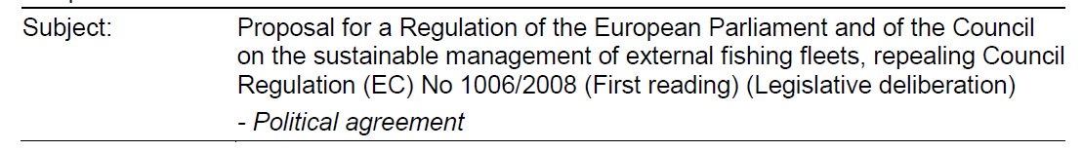
<container name="titleOfDocument">
<p><inline name="label">Subject:</inline>
<docTitle> Proposal for a Regulation of the European Parliament and of the Council on the sustainable management of external fishing fleets, repealing Council Regulation (EC) No 1006/2008 (First reading) (Legislative deliberation) <eol/>
- Political agreement</docTitle></p>
</container>

<collectionBody>
It contains one <component> per subdocument.

<component>
The <component> MUST contain a <documentRef> with the following mandatory attributes:
- @href containing the path to the file containing the subdocument;
- @showAs contains <preface>/<longTitle>/<docType> of the corresponding subdocument if exists, <preface>/<longTitle> else.
The <component> CAN contain, before the <documentRef> a <num> element (when the CNSDocANN is preceded the word "ANNEX…").

Examples
The following examples show the mark-up of the <documentCollection>:
- The general case of Council internal document,
- The statement of Council's reasons,
- The Position of the Council
- A draft act.
Only the most interesting mark-up are shown regarding the type of the document and the split into component(s). The official instances attached with this specification will contain the full mark-up of the <documentCollection> of these examples.

The general case of Council internal document
The following document (CoV_DLV20_1.09) is composed of one "Council Explanatory" and one CNSDocANN that is a consolidation of an extract of a bill,

The markup of the <documentCollection> (main.xml) will be the following:
<documentCollection name="INTERNAL_DOC_CONSIL"> <!-- or name="NOTE" -->
<meta>
<references source="~PUBL">
...
<TLCReference xml:id="INTERNAL_DOC_CONSIL" name="docType"
href="http://publications.europa.eu/resource/authority/resource-type/INTERNAL_DOC_CONSIL" showAs="Council internal document"/>
<TLCReference xml:id="NOTE" name="docType"
href="http://publications.europa.eu/resource/authority/resource-type/NOTE"
showAs="Note"/>
...
</references>
</meta>
<coverPage>
...
<container name="typeOfDocument">
<p><docType refersTo="~NOTE">NOTE</docType></p>
</container>
...
</coverPage>
<collectionBody>
<component>
<documentRef href="....xml" showAs="Explanatory"/>
</component>
<component>
<num>ANNEX</num>
<documentRef href="....xml" showAs="REGULATION OF THE EUROPEAN PARLIAMENT AND OF THE COUNCIL"/>
</component>
</collectionBody>
</documentCollection>

Statement of Council's reasons
The Statement of Council's reasons (CoV DLV20 1.5A) is composed of a "Council Explanatory".

The markup of the <documentCollection> (main.xml) will be the following:
<documentCollection name="INTERNAL_DOC_CONSIL">
<!-- or <documentCollection name="STAT_REASON"> -->
<meta>
...
<references source="~...">
<TLCReference xml:id="STAT_REASON" name="docType"
href="http://publications.europa.eu/resource/authority/resource-type/STAT_REASON"
showAs="Statement of reasons"/>
<TLCReference xml:id="INTERNAL_DOC_CONSIL" name="docType"
href="http://publications.europa.eu/resource/authority/resource-type/INTERNAL_DOC_CONSIL" showAs="Council internal document"/>
...
</references>
</meta>
<coverPage>
...
<container name="typeOfDocument">
<p><docType refersTo="~STAT_REASON">STATEMENT OF THE COUNCIL'S REASONS</docType></p>
</container>
...
</coverPage>
<collectionBody>
<component>
<documentRef href="....xml" showAs="Explanatory"/>
</component>
</collectionBody>
</documentCollection>

The Position of the Council
The Position of the Council (CoV DLV20 1.5A) is composed of a CNSDocANN, without Council explanatory.

The markup of the <documentCollection> (main.xml) could be the following (the <documentCollection> can have up to 3 differents values to represent different phases in the life of the document (for example, drafting phase, finalization, diffusion, …):
<documentCollection name="INTERNAL_DOC_CONSIL"> <!-- or <documentCollection name="POSIT">
or <documentCollection name="ACTS_LEGIS_INSTRUMENTS"> -->
<meta>
...
<references source="~...">
<TLCReference xml:id="ACTS_LEGIS_INSTRUMENTS" name="docType"
href="http://publications.europa.eu/resource/authority/resource-type/ACTS_LEGIS_INSTRUMENTS" showAs="Legislative acts and other instruments"/>
<!-- Depending on the value of the @name attribute of the <documentCollection>, -->
<TLCReference xml:id="INTERNAL_DOC_CONSIL" name="docType"
href="http://publications.europa.eu/resource/authority/resource-type/INTERNAL_DOC_CONSIL" showAs="Council internal document"/>
<!-- or -->
<TLCReference xml:id="POSIT" name="docType"
href="http://publications.europa.eu/resource/authority/resource-type/POSIT"
showAs="Position"/>
...
</references>
</meta>
<coverPage>
...
<container name="typeOfDocument">
<p><docType refersTo="~ACTS_LEGIS_INSTRUMENTS">LEGISLATIVE ACTS AND OTHER
INSTRUMENTS</docType></p>
</container>
...
</coverPage>
<collectionBody>
<component>
<documentRef href="....xml" showAs="DECISION No …/2013/EU OF THE EUROPEAN PARLIAMENT
AND OF THE COUNCIL"/>
</component>
</collectionBody>

The Council internal document with (draft) act
Like the Position of the Council (CoV DLV20 1.5A), the document is composed of a CNSDocANN, without Council explanatory.
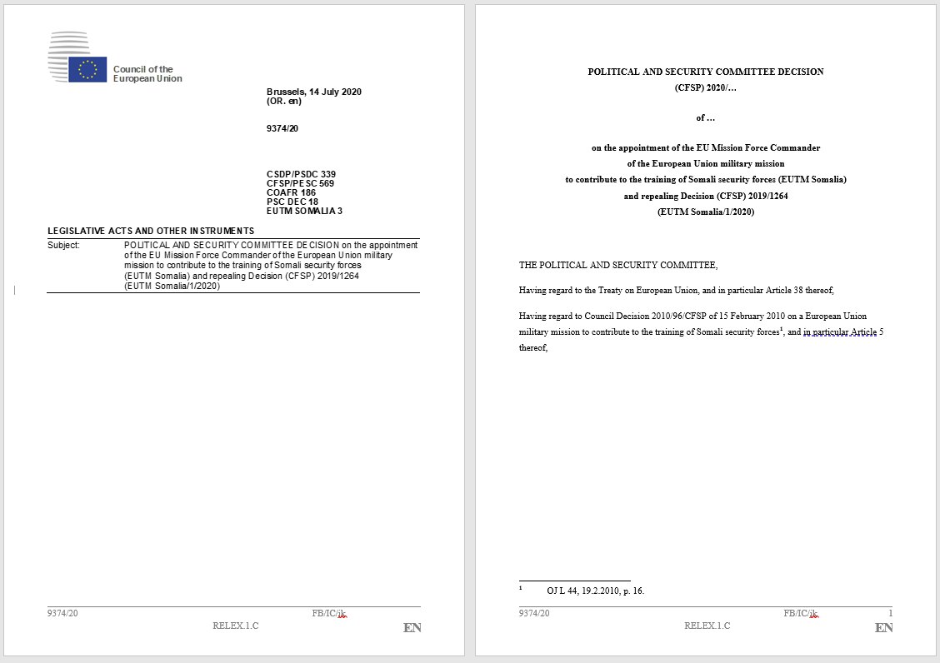
The markup of the <documentCollection> (main.xml) could be the following (the <documentCollection> can have 2 differents values, the generic one and ACTS_LEGIS_INSTRUMENTS to indicate that the document contains a draft act.
<documentCollection name="INTERNAL_DOC_CONSIL"> <!-- or <documentCollection name="ACTS_LEGIS_INSTRUMENTS"> -->
<meta>
...
<references source="~_...">
<TLCReference xml:id="ACTS_LEGIS_INSTRUMENTS" name="docType"
href="http://publications.europa.eu/resource/authority/resource-type/ACTS_LEGIS_INSTRUMENTS" showAs="Legislative acts and other instruments"/>
<!-- Depending on the value of the @name attribute of the <documentCollection>, -->
<TLCReference xml:id="INTERNAL_DOC_CONSIL" name="docType"
href="http://publications.europa.eu/resource/authority/resource-type/INTERNAL_DOC_CONSIL" showAs="Council internal document"/>
...
</references>
</meta>
<coverPage>
...
<container name="typeOfDocument">
<p><docType refersTo="~ACTS_LEGIS_INSTRUMENTS">LEGISLATIVE ACTS AND OTHER
INSTRUMENTS</docType></p>
</container>
...
</coverPage>
<collectionBody>
<component>
<documentRef href="....xml" showAs="POLITICAL AND SECURITY COMMITTEE DECISION"/>
</component>
</collectionBody>

The mark-up of the 'Council Explanatory' subdocument
This subdocument is marked with a <doc> element

The @name attribute
The <doc> element used to mark-up the 'Council Explanatory' has a mandatory attribute @name with always the value "EXPLANATORY_COUNCIL".

Overall organization
This subdocument has the following structure:
- <meta> mandatory (metadata)
- <preface> mandatory
- <mainBody> mandatory

<meta>
The following metadata are needed:
- The metadata required by AKN4EU (see AKN4EU PART1 – section 9.5),
The @value of the <FRBRprescriptive> metadata MUST be set to "false".
- For the value of the @name attribute of the <doc>,
it must exist, as metadata, a <TLCReference name="docType"> with the information on the corresponding entry in the authority table "resource-type" (the authority code is the value of the attribute @name)(see example below)

<preface>
The preface MUST always be present in the XML instance even if the title is not rendered.
In the case the title is not rendered, the attribute @status of the <preface> is set to “ignored”.
The <longTitle> contains the document type of this document (<docType>). The <docType> MUST have a @refersTo attribute with a reference to the corresponding entry in the <references> part of metadata.
<doc name="EXPLANATORY_COUNCIL">
<meta>
<TLCReference xml:id="EXPLANATORY_COUNCIL" name="docType"
href="http://publications.europa.eu/resource/authority/resource-type/EXPLANATORY_COUNCIL" showAs="Council explanatory"/>
…
</meta>
<preface status="ignored">
<longTitle>
<p><docType refersTo="~EXPLANATORY_COUNCIL">Explanatory</docType></p>
</longTitle>
</preface>
<mainBody>
…
</mainBody>
</doc>

<mainBody>
Drafting especially of Council internal documents requires due flexibility for the drafer in the composition of his document structures. When a user start drafting he/she might not know what would be the final structure of his draft as it is closely related on the complexity of the text itself that can evolve during the drafting.

The structures
The main part of a Council Explanatory can have the following structure:
- unnamed structures in flat model
4 different types are defined: "type_1", "type_2", "type_3" and "type_4"; each type has a specific rendering.
To harmonize the document, there are constraints on the use of these types of unnamed structures, depending on the context.
- independent points.
- independent subjects inside the document without numbering systems.
These subjects must be more viewed as bookmark. They can have bullet or indent character at the beginning.
Example

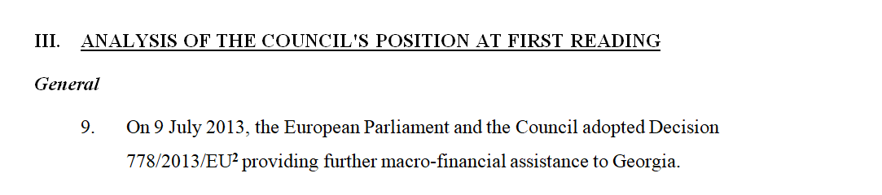
Unnamed structure
Independent point
Independent subject

The representation in AKN4EU

The unnamed structure in flat model (<division>)
This element MUST CONTAIN one "heading" (<num>) and one "subject" (<heading>).
It CANNOT contain any other element.
<division> MUST contain a @class attribute with one of these following value (in this order):
- "type_1"
<division> of first type
- "type_2"
<division> of second type
- "type_3"
<division> of thirth type
- "type_4"
<division> of the fourth type

The independent subject
(<crossHeading> or <block name="crossHeading">)
The independent subject is represented
- by the element <crossHeading> inside an Akoma Ntoso hierarchical element (<level>, <point>),
- by the element <block name="crossHeading"> outside an Akoma Ntoso hierarchical element.
The <crossHeading> can be mixed with (= at the same level as)
- <subparagraph>, <list>, <point>, <indent>.
The <block name="crossheading"> can be mixed (= at the same level as)
- <division>
- <paragraph>, <level>
An independent subject can have bullet or indent.
In this case, the bullet or indent are marked as
<inline> with the mandatory attribute @name set to "crossHnum"
Example
<block name="crossheading">
<inline name="crossHnum">•</inline> …
</block>
Or
<crossHeading>
<inline name="crossHnum">-</inline> …
</crossHeading>

The mark-up of highlighting
The following new elements are defined, as they are used frequently inside the "Council Explanatory", in the Council internal documents:
- To mark-up a text that is strikethrough: <span class="strikethrough">

<p>New text compared to <u>the Commission proposal</u> is indicated in <b>bold</b>. Deletions are marked by <span class="strikethrough">strikethrough</span>.</p>

Example
Taking the following example:
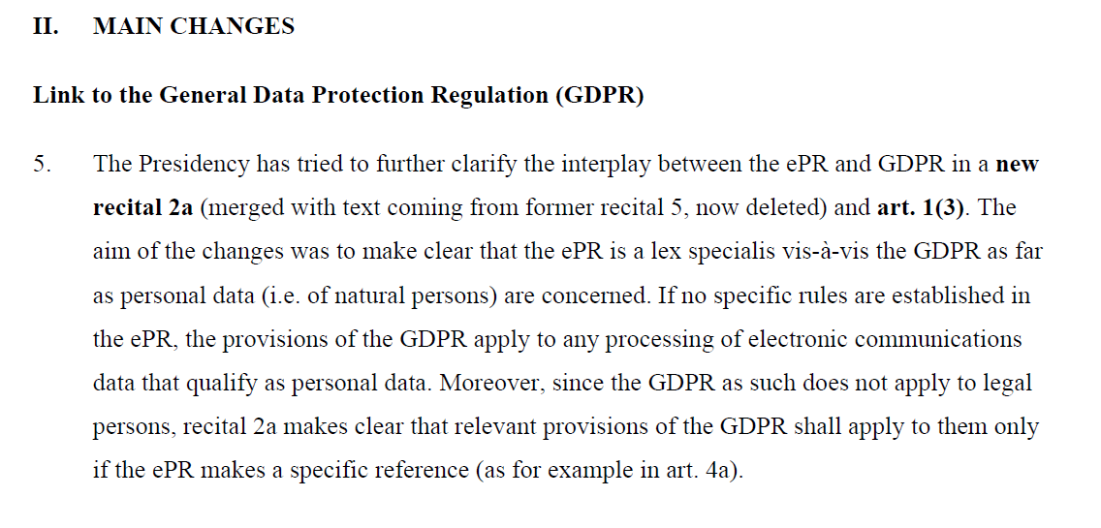
The representation in AKN4EU will be the following:
<division>
<num>II.</num>
<heading>MAIN CHANGES</heading>
</division>
<block name="crossHeading">Link to the General Data Protection Regulation (GDPR)</block>
<level>
<num>5.</num>
<content>
<p>The Presidency has tried to further clarify the interplay between the ePR and GDPR in a <b>new recital 2a</b> (merged with text coming from former
recital 5, now deleted) and <b>art. 1(3)</b>. The aim of the changes was
to make clear that the ePR is a lex specialis vis-à-vis the GDPR as far
as personal data (i.e. of natural persons) are concerned. If no specific
rules are established in the ePR, the provisions of the GDPR apply to
any processing of electronic communications data that qualify as
personal data. Moreover, since the GDPR as such does not apply to legal
persons, recital 2a makes clear that relevant provisions of the GDPR
shall apply to them only if the ePR makes a specific reference (as for
example in art. 4a).</p>
</content>
</level>
…

The mark-up of the CNSDocANN
A "Council doc annex" (CNSDocANN) can be
- An <act> or <bill> (Regulation, Directive, Decision) ( "Position of the Council", autonomous acts, ...)
- A consolidated version of a <bill> or fragments of consolidated version of <bill>.
- A <doc> with a specific document type (Council conclusions for example: <doc name=”CONCL”>)
- Any other text without specific type
<doc name “DOC”>.

All CNSDocANN must have as metadata at least the standard metadata
- The metadata required by Akoma NtosoAKN4EU (see AKN4EU PART1 – section 9.5<identification> section, as defined in AKN4EU 4.1 baseline),
The @value of the <FRBRprescriptive> metadata MUST be set to "true" or “false” depending on the type of CNSDocANN.

Act or bill
The CNSdocANN can be an <act> or a <bill> element.

The @name attribute
The attribute @name can be "DEC", "DIR" or "REG"

Overall organization
The structure of the document is the classical structure of <act> or <bill>.
It can have one or more annexes.
In this case, the <act> (or the <bill>) contains an <attachments> section with one <attachment> element per annex.
Example

The CNSDocANN content will be marked as following:
<bill name="DEC">
<meta>
...
<references source="~...">
<TLCReference xml:id="DEC" name="docType"
href="http://publications.europa.eu/resource/authority/resource-type/DEC"
showAs="Decision"/>
...
</references>
</meta>
<preface>
...
</preface>
<preamble>
...
</preamble>
<body>
...
</body>
<conclusions>
...
</conclusions>
<attachments>
...
<attachment>
<documentRef href="....xml" showAs="ANNEX ..."/>
</attachment>
...
</attachments>
</bill>

<meta>
All CNSDocANN must have as metadata at least the standard metadata
- The metadata required by AKN4EU (see AKN4EU PART1 – section 9.5),
The @value of the <FRBRprescriptive> metadata MUST be set to "true".
- For the value of the @name attribute of the <bill>,
it must exist, as metadata, a <TLCReference name="docType"> with the information on the corresponding entry in the authority table "resource-type" (the authority code is the value of the attribute @name).

<preface>
The mark-up follows the general mark-up for "EU acts" (See AKN4EU PART 2 – 2.1 EU acts).

<body>
The mark-up follows the general mark-up for "EU acts" (See AKN4EU PART 2 – 2.1 EU acts).

<conclusions>
The mark-up follows the general mark-up for "EU acts" (See AKN4EU PART 2 – 2.1 EU acts).

Fragment(s) of consolidated version of a document

Introduction
During the Council internal workflow, in the context of legislative procedures, the Council internal documents are exchanged as basis for the discussion of the final Position of the Council.
For the Ordinary Legislative Procedure, the workflow starts with the reception of the Proposal for an Act issued from the Commission and ends with the final Position of the Council.
The intermediate Council internal documents are generally focused on one or more fragments of the Proposal and highlight the already accepted changes of the proposal and the new changes.

The AKN4EU content of the CNSDocANN
For the mark-up of the CNSDOcANN that is a consolidated fragment of a another document (<bill> or <doc>), the AKN4EU file always includes the whole current version of the document and the subdivisions that are not displayed are indicated by using a @status attribute set to “ignored”.
The advantage of this method is to have always the complete last version of the bill without complex merges of multiples CNSDocANN.
The CNSDocANN as an XML file contains the whole <bill> with all the modifications already adopted; not visible parts of the <bill> have the attribute @status sets to ”ignored” .
The following picture shows a Council internal document with 2 CNSDocANN. The first one is a consolidated fragment of bill. In AKN4EU, the overall <bill> is present, not visible part have the attribute @status=”ignored” (shaded)
.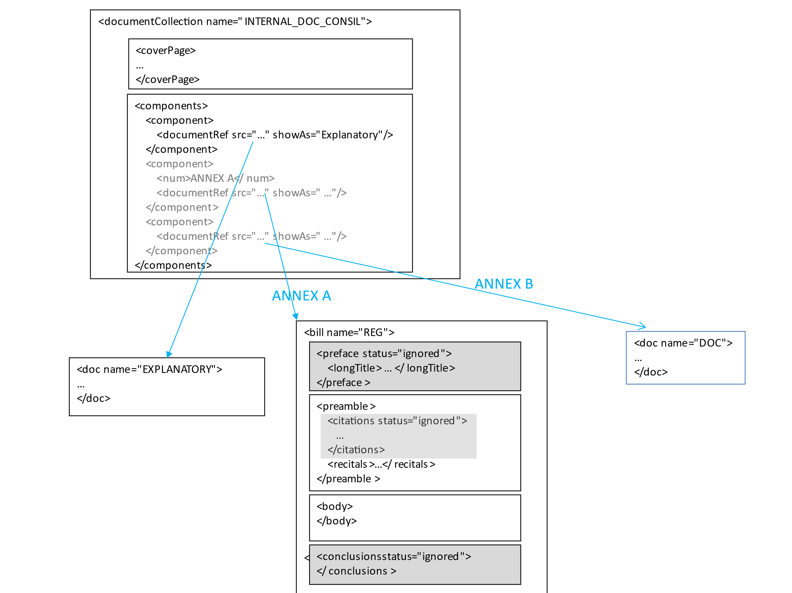

General structure in the case of <bill>
See AKN4EU PART 2 – 2.1 EU acts

The specific mark-up inside the consolidated version of a document
These mark-up allows to mark the track changes inside the <bill>.

Any modification compared to the original version of the document is marked as following:
- <ins> is used to mark the insertion of text
- <del> is used to mark the deletion of text
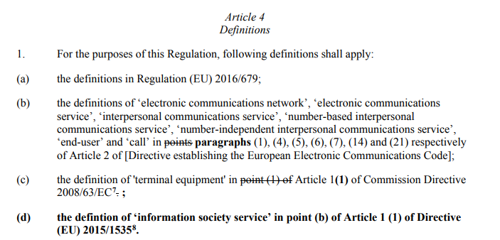
The mark-up will be the following:
<?xml version="1.0" encoding="UTF-8"?>
<article>
<num>Article 4</num>
<heading>Definitions</heading>
<paragraph>
<num>1.</num>
<list>
<subparagraph refersTo="~INP"><content>
<p>For the purposes of this Regulation, following definitions shall apply: </p>
</content></subparagraph>
<point>
<num>(a)</num>
<content>
<p>the definitions in Regulation (EU) 2016/679; </p>
</content>
</point>
<point>
<num>(b)</num>
<content>
<p>the definitions of ‘electronic communications network’, ‘electronic communications service’, ‘interpersonal communications service’, ‘number-based interpersonal communications service’, ‘number-independent interpersonal communications service’, ‘end-user’ and ‘call’ in <del>points</del><ins>paragraphs</ins> (1), (4), (5), (6), (7), (14) and (21) respectively of Article 2 of [Directive establishing the European Electronic Communications Code]; </p>
</content>
</point>
<point>
<num>(c)</num>
<content>
<p>the definition of 'terminal equipment' in <del>point (1) of </del>Article 1<ins>(1)</ins> of Commission Directive 2008/63/EC<authorialNote placement="bottom" marker="10"><p>Commission Directive 2008/63/EC of 20 June 2008 on competition in the markets in telecommunications terminal equipment (OJ L 162, 21.6.2008, p. 20–26).</p></authorialNote><del>.</del><ins>;</ins>
</p>
</content>
</point>
<point>
<num>
<ins>(d)</ins>
</num>
<content>
<p>
<ins>the defintion of ‘information society service’ in point (b) of Article 1 (1) of Directive (EU) 2015/1535<authorialNote placement="bottom" marker="11"><p>Directive (EU) 2015/1535 of the European Parliament and of the Council of 9 September 2015 laying down a procedure for the provision of information in the field of technical regulations and of rules on Information Society services (OJ L 241, 17.9.2015, p. 1-15).</p></authorialNote>.</ins>
</p>
</content>
</point>
</list>
</paragraph>
</article>

Document (Council conclusions for example)
The CNSdocANN can be a <doc>.
The attribute @name for the ‘Council conclusions’ is " CONCL".
The structure of the document is identical to the structure of the "Council explanatory" except the fact that there can have a title of the document to display.

Overall organization
This subdocument has the following structure:
- <meta> mandatory (metadata)
- <preface> mandatory
- <mainBody> mandatory
- <attachments> mandatory if it has annex(es)

<meta>
- The metadata required by AKN4EU (see AKN4EU PART1 – section 9.5),The metadata required by Akoma Ntoso (<identification> section, as defined in AKN4EU 4.1 baseline),
The @value of the <FRBRprescriptive> metadata MUST be set to "false".
- For the value of the @name attribute of the <doc>,
it must exist, as metadata, a <TLCReference name="docType"> with the information on the corresponding entry in the authority table "resource-type" (the authority code is the value of the attribute @name)

<preface>
If the <preface> contains information to display, the <preface> has no @status (it must be displayed).
The <longTitle> MUST exist. If it is not to display, it has the @status set to "ignored".
<preface> can contain a <block name="crossheading">. When this is the case, this block must be rendered as an "header".
Example (CoV DLV20 1.19)
This example is special:
- The title of the Conclusions is not displayed
- In place, a text is put in the header of each page.
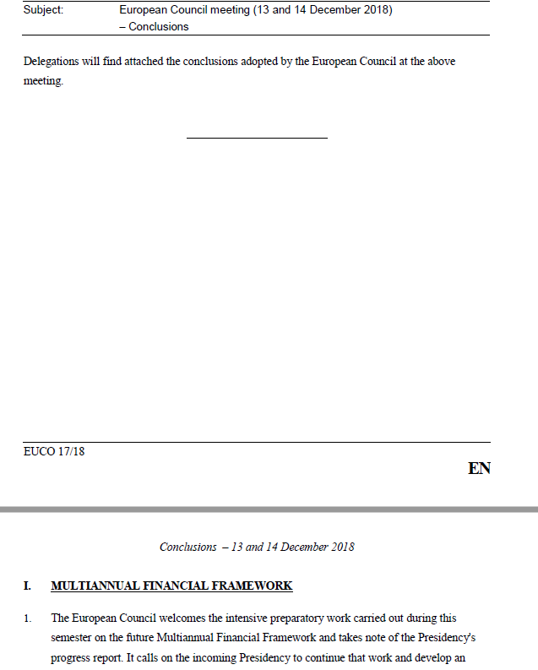
The <block name="crossheading"> in <preface> is displayed as header.
This is the text of the <longTitle> of the "<doc name="CONCL">
The AKN4EU mark-up of the <preface>:
- Set the @status of <longTitle> to "ignored"
- Add in the <preface> a <block name="crossheading">
<preface>
<longTitle status="ignored">
<p>European Council meeting (13 and 14 December 2018) – Conclusions</p>
</longTitle>
<block name="crossHeading">Conclusions – 13 and 14 December 2018</block>
</preface>

<mainBody>
Same as the 'Council Explanatory' subdocument.

Examples
Example (CoV DLV20 1.20)

The mark-up will be the following:
<doc name="CONCL">
<meta>
...
<references>
<TLCReference xml:id="CONCL" name="docType"
href="http://publications.europa.eu/resource/authority/resource-type/CONCL"
showAs="Council conclusions"/>
</references>
</meta>
<preface>
<longTitle>
<p>DRAFT <docType refersTo="~CONCL">COUNCIL CONCLUSIONS</docType> ON THE UPDATED BIOECONOMY STRATEGY "A SUSTAINABLE BIOECONOMY FOR EUROPE: STRENGTHENING THE CONNECTION BETWEEN ECONOMY, SOCIETY AND THE ENVIRONMENT"</p>
</longTitle>
</preface>
<mainBody>
<paragraph>
<content>
<p>The Council of the European Union:</p>
</content>
</paragraph>
<level>
<num>1.</num>
<list>
<subparagraph refersTo="~INP">
<content>
<p>RECALLING:</p>
</content>
</subparagraph>
<indent>
<num>–</num>
<content>
<p>The European Council conclusions of March 2019, which underlined a strong economic base as of key importance for Europe's prosperity and competitiveness, and in view of a globally integrated sustainable and competitive industrial base, invited the Commission to present by the end of 2019 a long term vision for the EU's industrial future, touching upon all relevant policy areas<authorialNote marker="1" placement="bottom"> <p>EUCO 1/19</p> </authorialNote>;</p>
</content>
</indent>
<indent>
<num>–</num>
<content>
<p>the European Council on 20 June 2019, where the European Council invited the Council and the European Commission to advance work on conditions, the incentives and the enabling framework to put in place so as to ensure a transition to a climate neutral EU in line with the Paris agreement<authorialNote marker="2" placement="bottom"><p>EUCO 9/19</p></authorialNote>;</p>
</content>
</indent>
</list>
</level>
</mainBody>
</doc>

Depending on the context, an annex may represent different realities, such as ANNEX, APPENDIX etc. In the description below, ‘annex’ is used in a generic sense, covering all these cases.
Entry of the authority table 'resource-type’.
When there is only one recital, the introductory text is normally not present in the EU acts.
"Continuously" means that the number of the article is incremented along the document regardless of the higher structure containing the article (e.g. no initiation of article numbering at the beginning of each chapter). This is different to the numbering of the paragraphs, which are numbered discontinuously (re-initialisation within each article).
This division remains only for historical reason but is not used anymore.
Joint Practical Guide (2015) § 15.4
https://publications.europa.eu/en/web/eu-vocabularies/at-dataset/-/resource/dataset/place
https://publications.europa.eu/en/web/eu-vocabularies/at-dataset/-/resource/dataset/corporate-body
https://publications.europa.eu/en/web/eu-vocabularies/at-dataset/-/resource/dataset/role
See Joint Practical Guide, 22.B., p. 75 – Legal acts attached to other acts
https://publications.europa.eu/en/web/eu-vocabularies/authority-tables
@showAs may depend on the way the user called the Annex.
Akoma Ntoso does not allow a <heading> element as sub-element of <preamble>.
https://publications.europa.eu/en/web/eu-vocabularies/authority-tables
“COM_NUMBER_INTERNAL” entry in the authority table document-identifier-format
The internal reference is used by some DG's to identify the document internally when shared with different users/services. They are internal to the Commission.
For preparatory documents that are related to an interinstitutional procedure, an ELI URI exists. The syntax is the following: http://data.europa.eu/eli/dl/proc/[year]/[seq_num]/[proc_Type]/doc/com/[com_number]/[version]
CELEX alternative will be : http://publications.europa.eu/resource/celex/52022PC0459
This example has been created for the need of the specification. It is not the cover page of a real document.
This <container> is not part of the specification and is only for the example purpose.
With the syntax of ELI-DL, it will be “http://data.europa.eu/eli/dl/proc/2015/268/cod/doc/com/COM_2015_826”
In this case, the <references> part of metadata MUST have a <TLCReference name="docType"> for the "PROP_ACT" definition.
If the keywords are part of an authority table, a <term> can be used with a reference to the corresponding TLCTerm in the references part of the metadata.
The next release of Akoma Ntoso will correct this, allowing to have <crossheading> outside the Akoma Ntoso hierarchical element.

